Tuesday 19th January 2021
1a draw on knowledge of vocabulary to understand texts.

Read the reading page text and draw a line to match up the words to their correct picture.
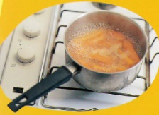
Open fire
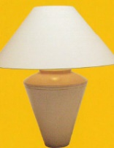
Burning candle
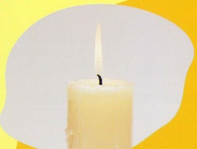
Modern cooker
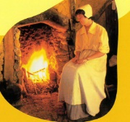
Electric light

- Which two items would you find in a house in 1666?
____________________________________ _______________________________________
- Which two would you find in a modern house?
_____________________________________ _______________________________________
Challenge
Which items are safer and why?
__________________________________________________________________________________________________________________________________________________________________________________________________________________________________________________________________________________________________________________

