Monday 18th January, 2021
1b identify / explain key aspects of fiction and non-fiction texts, such as characters, events, titles and information

Read the text and talk about the houses in 1666 with an adult.
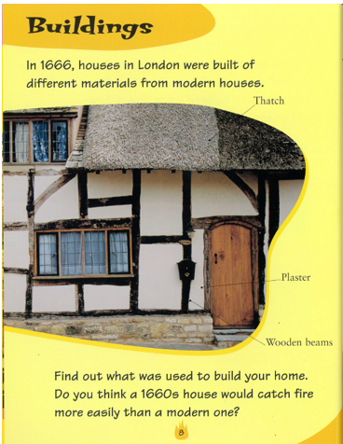

- What does the word modern mean?

- What three materials were used to build houses in 1666?

_____________________________________
_____________________________________
_____________________________________

