Tuesday 12th January 2021
LI: To use vocabulary to understand the story.
I can talk about characters from a familiar story.
I can use my phonic knowledge for spelling.
I can form most letters correctly.
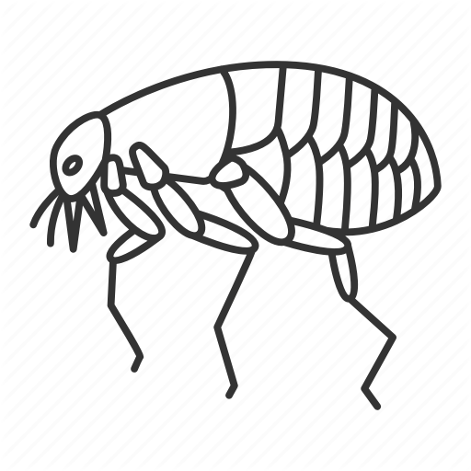
Fill in the spaces inside the flea to describe how Vlad might be feeling throughout the story. Fill in the spaces around the outside of the flea to describe what Vlad looks like.

