Wednesday 13th January 2020
LI: To write a character description using an expanded noun phrase.
I can talk about characteristics.
I can use adjectives for description.
I can write an expanded noun phrase.

Change the red words in the giant’s character description using your flea template from yesterday to create a new character description for Vlad.
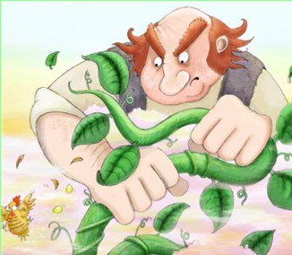
He was huge with big, scary eyes and a grumpy face. He was exhausted after trying to catch the hen that lays the golden eggs.

