13.1.2021
LI: To be able to identify halves
I am able to understand that a half is splitting a whole into 2
I am able to write a half as a fraction.
Draw as a bar model to help you. One has been done for you.
4
2 | 2
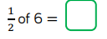
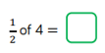

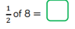

Half of 20

Half of 30

Half of 44

How do you write a half as a fraction?

