18.01.2021
LI: To find quarter of a shape
I know quarters are 4 equal parts of a whole
I can quarter a shape
I can find more than one way to find a quarter
Cut out the shapes. Fold and cut in quarters.
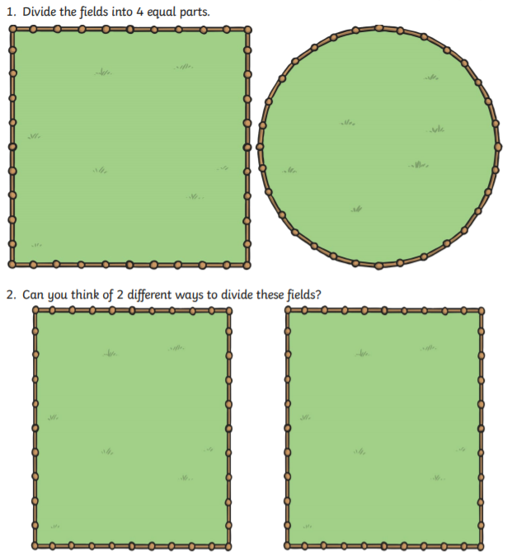

Challenge