19.01.2021
LI: To find a quarter of an amount.
I know quarters are 4 equal parts of a whole
I can share into 4 groups to find a quarter of an amount.
Can you fill in this table by sharing
amounts into quarters?
Whole amount | One quarter
4
8
16
20
12
24

You could use pennies, pasta shapes, small toys, lego bricks to help you or cut out the sheep counters below.
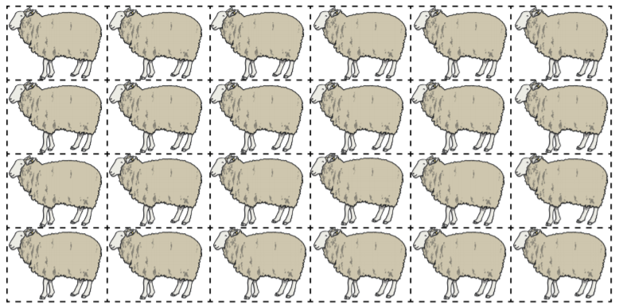

Challenge
