LI: To use multiplying and dividing by 100 to find related facts.
I will be successful if:
I can use a place value grid and write the digits in the correct column.
I can move the digits left to multiply and right to divide.
I can recognise and understand that multiplication is the inverse of division.

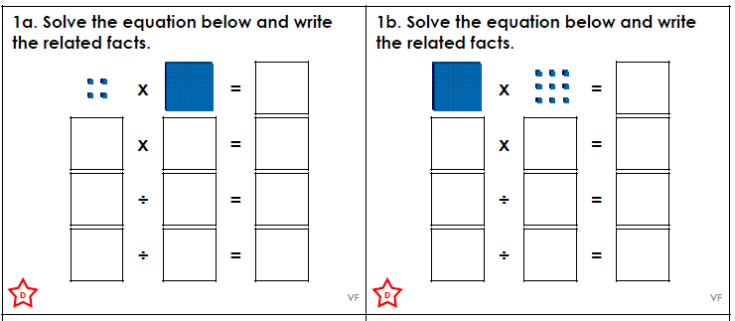
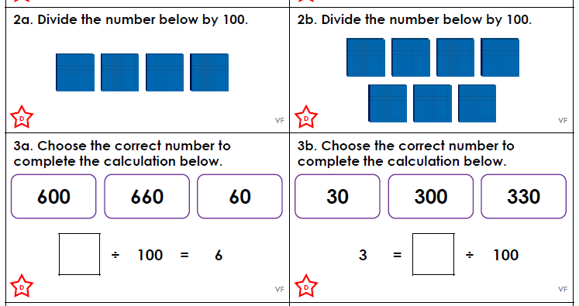
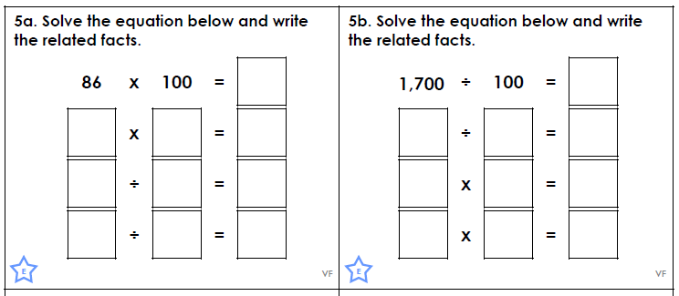

Challenge
Have a go at these challenges. There could be more than one solution. Don’t forget to reason and explain how you got the answer!
