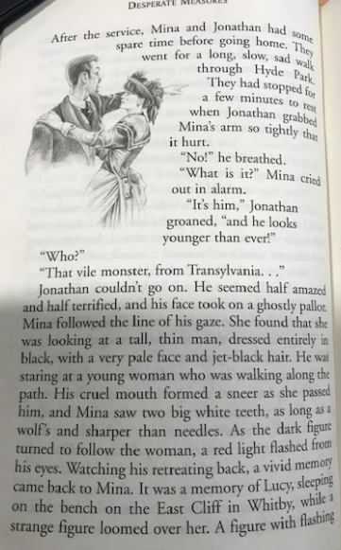
Skill Check: Retrieve and Record (2b)

Page 60
The main idea. Tick the phrase that sums up the main idea
- The funeral
- Jonathan is scared
- Count Dracula is discovered in London
- Mina remembers about Whitby.

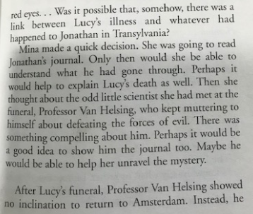
Page 61

- Mina is worried about Jonathan
- Mina decides to read the journal
- Mina think Van Helsing could help.

Question Time
Tick Two.
What are the books which Van Helsing reads?
- The Unknown Powers
- How to Kill a Vampire
- Battling the Dead
- Vampire Arts

What makes Van Helsing stay in London?
___________________________________________________________________________
What is similar about the injuries on the victims and Lucy?
___________________________________________________________________________
Why is Jack furious at Van Helsing?
___________________________________________________________________________
Name two ways in which Van Helsing wants to prove his theory about Lucy.
___________________________________________________________________________
What convinces Jack to go with the Professor?
___________________________________________________________________________
Predict it!
Why are they going to gather at Lucy’s tomb? What do you think they are going to do?
_____________________________________________________________________________________________________________________________________________________________________________________________________________________________________________________________________________________________________________________________________________________________________________________________________________________________________________________________________________________________________________________________________________

