Friday 8th January
Problem solving – using tables or lists
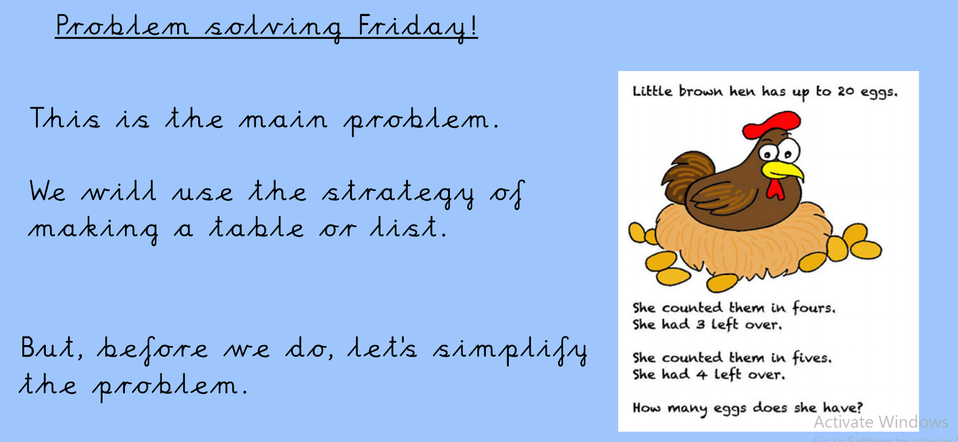
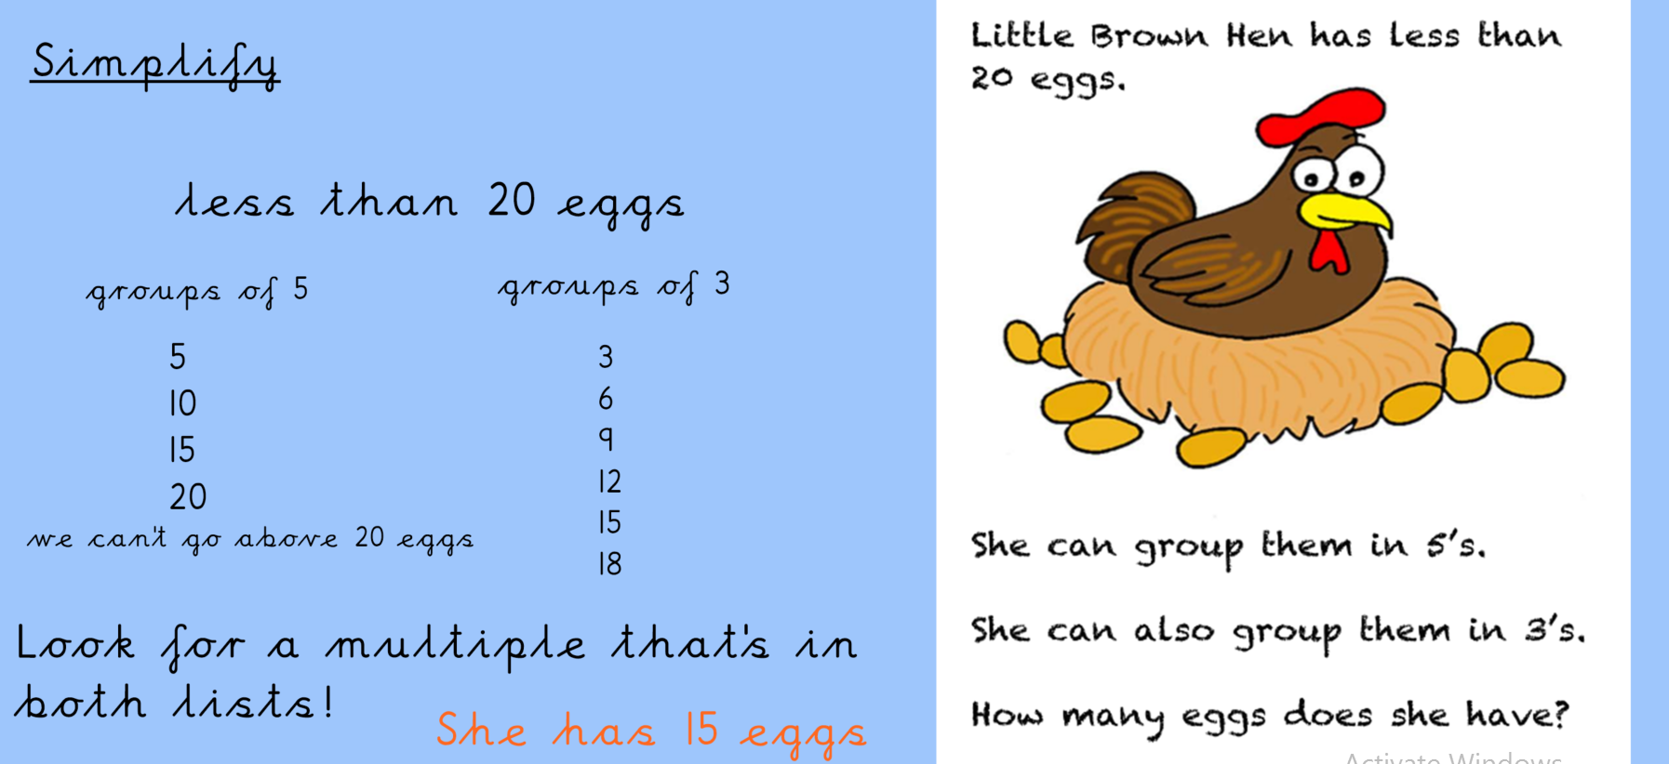
Now look back at the original problem.
When she groups the eggs, she has some left over.
