Wednesday
Maths Introduction
Read through the introduction and then have a go at one of the activities and challenges.
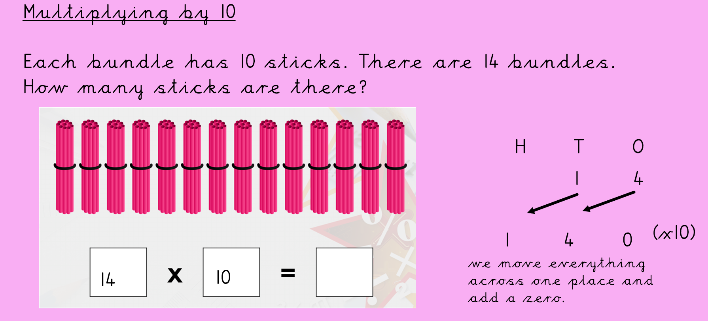
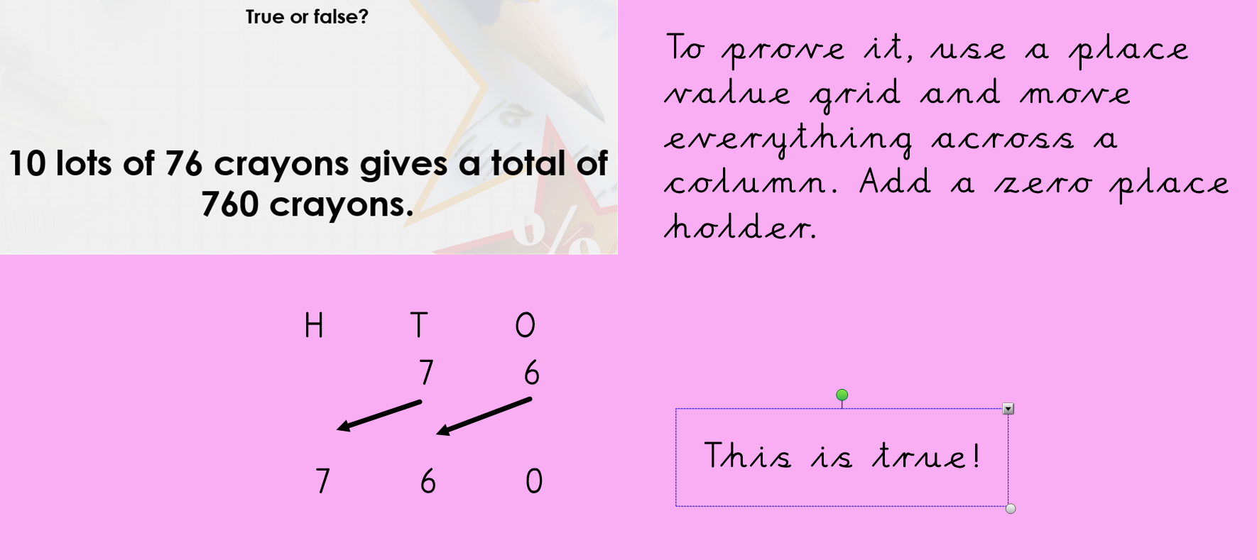
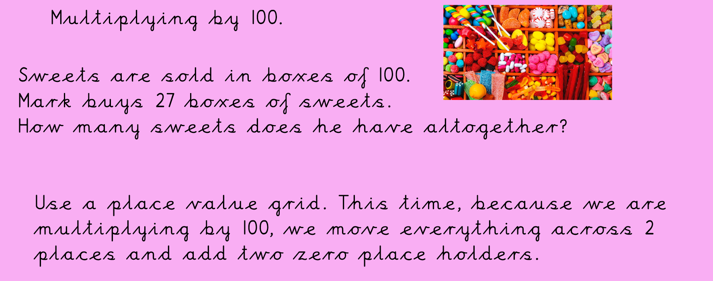
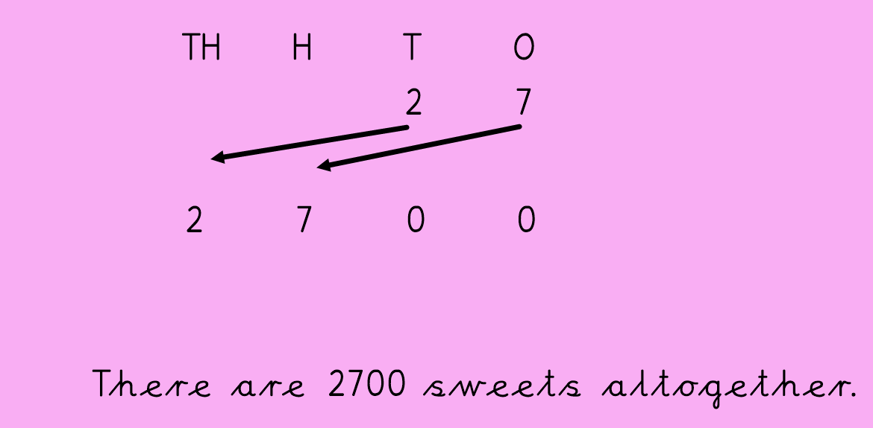
Now have a go at one of the main activities, multiplying by 10 or 100.
Complete a challenge afterwards.

