L.I:- To be able to recognise how erosion has effected the coast line of Whitby.
I will be successful if..
- I can name the 3 different types of erosion and their processes.
- I can explain what has changed over time of the coastline.
- I can discuss the effect on human and physical geography.
Can you recall the location of Whitby?

What is erosion?

Can you name the 3 types of erosion on coastlines?

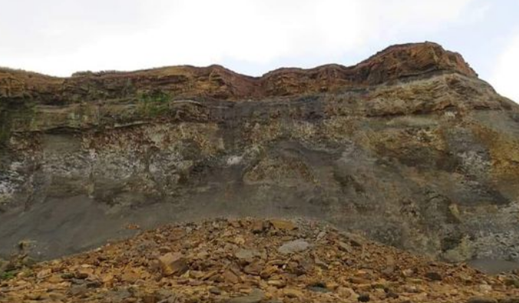
Describe what you can see in the image and what may have caused it?

What affect may this have on tourism in Whitby?
Physical features | Human features

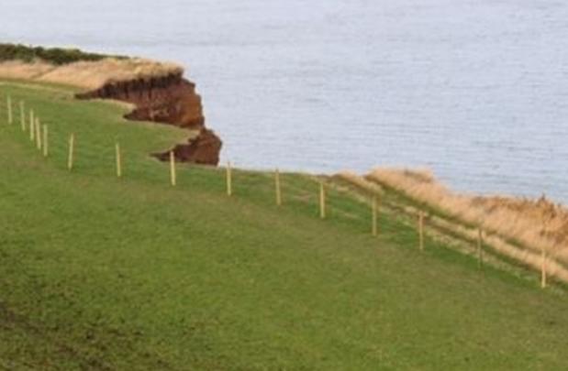
Describe the effect that coastal erosion could have on a tourist town.

What could we all do to help slow down the rate of coastal erosion? Think back to previous work.

