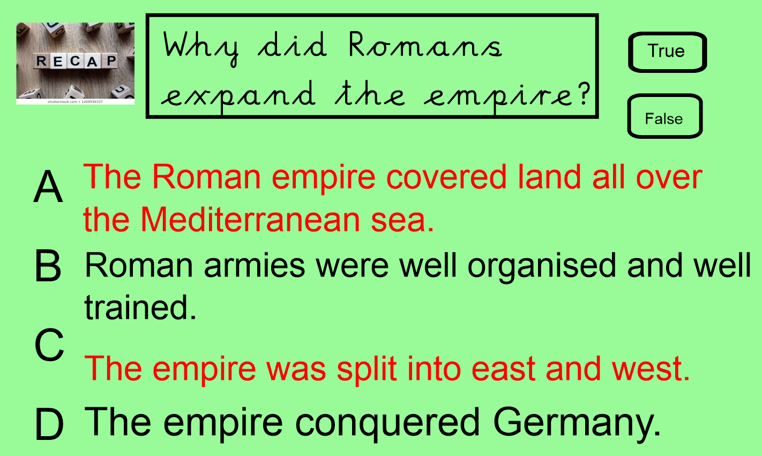
How did the Romans invade Britain?

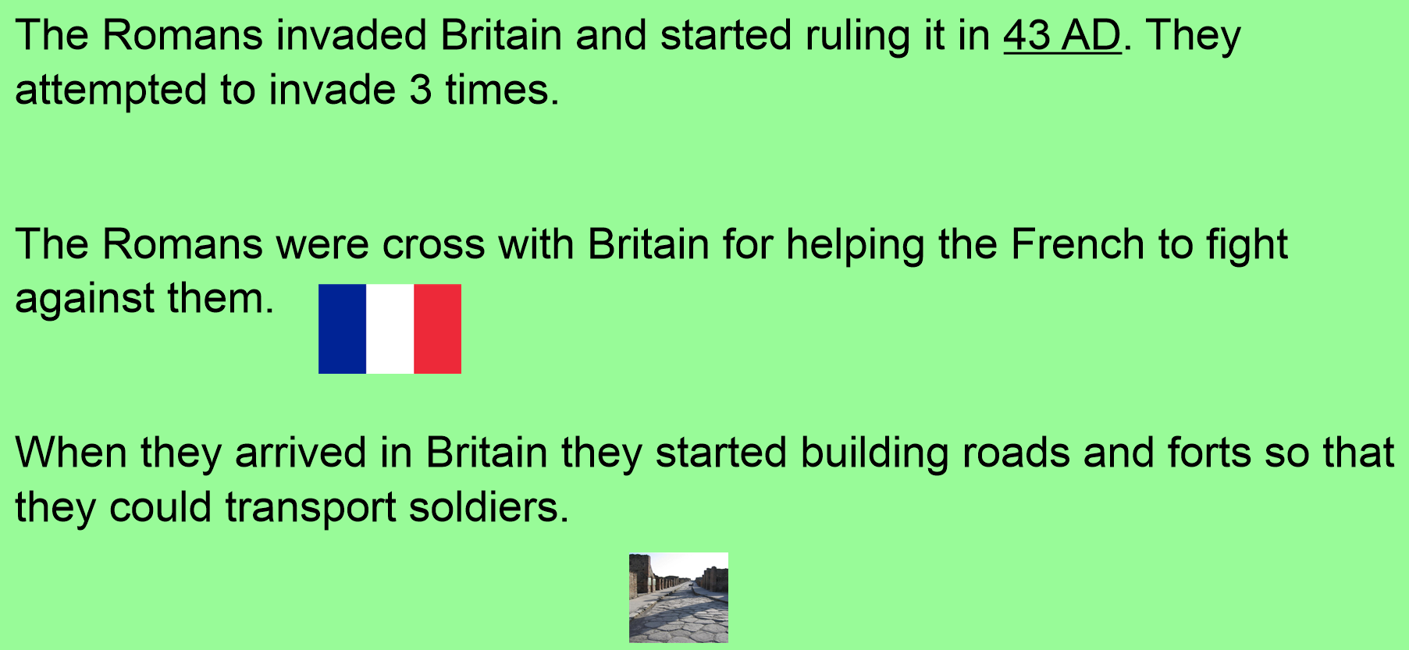

Can you match the riches to the image?
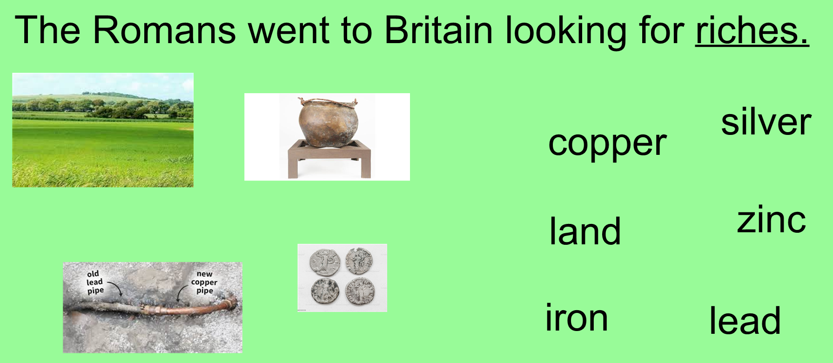
Watch this video:

Think about what you know about the Romans invading Britain.
Use the grid to tell me three things you know. Remember to write in full sentences.

