Skill Check: Retrieve and Record Information (2b)
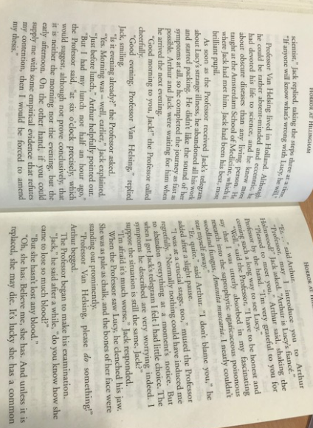
Ordering boxes activity
Van Helsing meets Arthur

Van Helsing examines Lucy

Van Helsing enquires about Lucy’s health

Arthur is confused by Van Helsing

Discusses Lucy loss of blood

Professor Van Helsing arrives

Question Time
What does Van Helsing demand for Lucy?
___________________________________________________________________________
Who provides blood for Lucy?
___________________________________________________________________________
Why does Arthur have to lie down after the blood transfusion?
___________________________________________________________________________
What concerns Van Helsing about Lucy’s clothing?
___________________________________________________________________________
Why are the marks on Lucy’s neck concerning to Jack?
___________________________________________________________________________
What symptoms of Lucy aroused Van Helsings suspicions? List 3.
___________________________________________________________________________
___________________________________________________________________________
___________________________________________________________________________
Why does Van Helsing want to go to the British Museum?
___________________________________________________________________________
Why do you think Van Helsing wants Jack to stay and watch over Lucy?
___________________________________________________________________________
Which one word shows the reader that Jack is upset at Van Helsings secrecy?
___________________________________________________________________________

