Describe Jonathan’s dream?
______________________________________________________________________________________________________________________________________________________
Why did Jonathan go to Transylvania? What were his motivations?
______________________________________________________________________________________________________________________________________________________
What was Jonathan thinking before he left? What were his actions?

What was Jonathan thinking during the journey? What were his actions?

What was Jonathan thinking when meeting the Count? What were his actions?

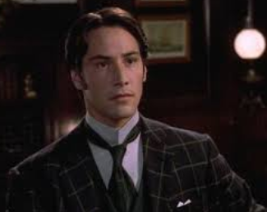
My Question:____________________________________________________
____________________________________________________________
Jonathan’s Answer: ___________________________________________
________________________________________________________________________________________________________________________________________________________________________________________________________________________________________________

My Question:____________________________________________________
____________________________________________________________
Jonathan’s Answer: ___________________________________________
________________________________________________________________________________________________________________________________________________________________________________________________________________________________________________

My Question:____________________________________________________
____________________________________________________________
Jonathan’s Answer: ___________________________________________
________________________________________________________________________________________________________________________________________________________________________________________________________________________________________________

