Pitstop 3
Find the pattern by looking at which animal comes first, then second, then third and then fourth.
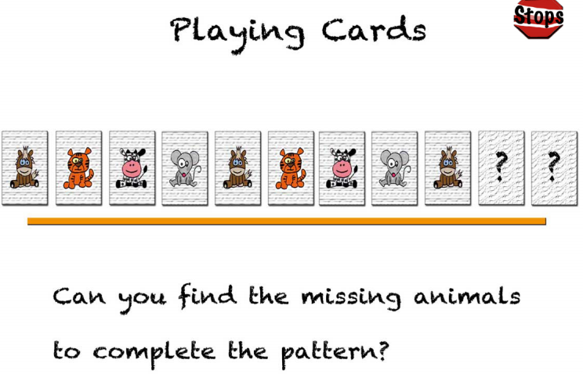
If you solve this problem easily, try having a go at the main problem.

