Spelling 5.01.21

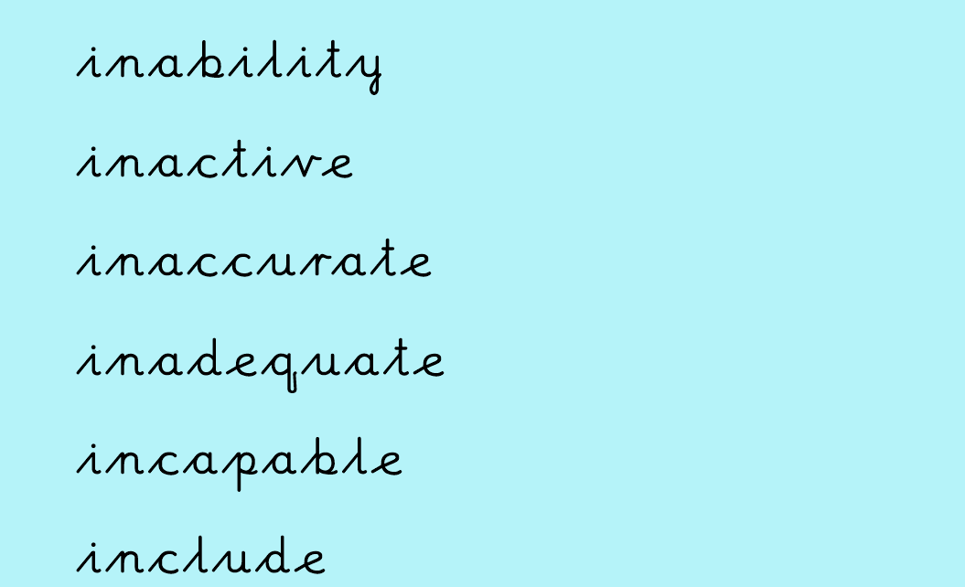
Say the word | Cover/write/check | Cover/write/check | Cover/write/check | Cover/write/check

