Jonathan’s Diary
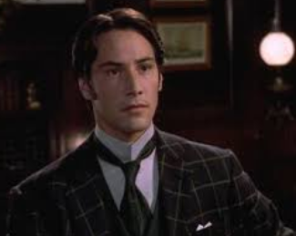
Before finally going to bed, Jonathan sat down at a desk and described the day’s events in his journal. It was a diary of all his Transylvanian experiences which he was keeping for Mina. He smiled as he wrote, imagining her reading it. She would laugh her head off at how nervous he had been earlier.
Write a diary entry from Jonathan explaining and describing his day.

