Skill Check: Retrieve and Record Information (2b)
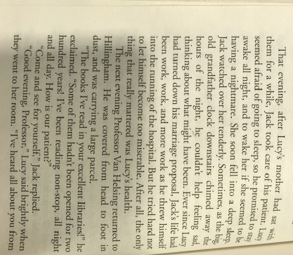
Find and copy one word/phrase.

Find and copy one word that shows that Jack is caring for Lucy kindly.
___________________________________________________________________________
Find and copy one word which shows that Lucy is feeling happier.
___________________________________________________________________________
Find and copy a phrase of words which mean the same as ‘constantly reading’
___________________________________________________________________________
Find and copy one word which is similar in meaning to the word night.
___________________________________________________________________________

Prove it!
Use the text to prove these statements.
- Lucy didn’t want to go to sleep.
- Jack had kept himself busy after Lucy refused to marry him.
- Van Helsing was pleased with Lucy’s improving health.
- Lucy didn’t like the smell of the flowers.
- Van Helsing orders Lucy to leave the window alone.
- Mrs Westenra got rid of the flowers.
- When they entered the room Lucy’s health had deteriorated

Infer it!
Why is Van Helsing upset at Mrs Westenra?
Explain your answer clearly using the text as evidence.
___________________________________________________________________________________________________________________________________________________________________________________________________________________________________________________________________________________________________________________________________________________________________________________________________________________________________________________________________________________________________________________________________________________________________________________________________________________________________________________________________________________________________

