Skill Check: Retrieve and Record Information (2b)
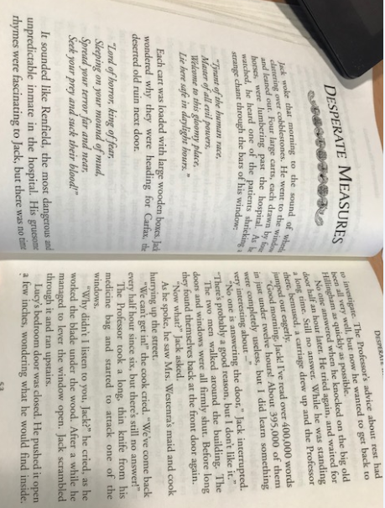
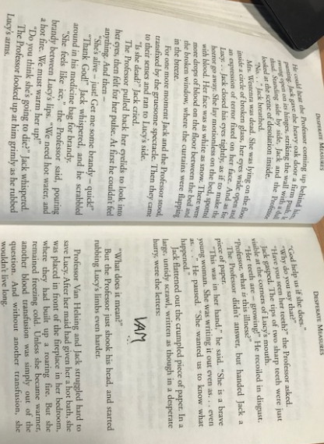
Fact or opinion?
 | Fact | Opinion
Renfield’s riddles were fascinating.

Jack waited for 30minutes outside Mrs Westenra’s house.
Van Helsing broke into the house.

The house was in disarray.

Lucy is valiant.

Question Time
Work out the answers to the riddles from the clues provided.
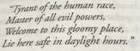
Who is the riddle about?
___________________________________________________________________________
What is important about daytime?
___________________________________________________________________________
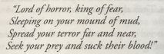
What impression of the character do you get from the riddle?
___________________________________________________________________________
What should people be afraid of?
___________________________________________________________________________

Infer it!
What evidence is there that Jack and the Professor are worried about Lucy and Mrs Westenra (page 53) Give two points.
______________________________________________________________________________________________________________________________________________________
How does Jack feel when he see’s Lucy on the bed? Justify your answer using the text.
__________________________________________________________________________________________________________________________________________________________________________________________________________________________________________________________________________________________________________________________________________________________________________________________________________________________________________________________________

Page 55. Tick one.
Lucy is courageous.
True
False
Justify your answer using the text as evidence.
__________________________________________________________________________________________________________________________________________________________________________________________________________________________________________________________________________________________________________________________________________________________________________________________________________________________________________________________________

