Wednesday
Skill Focus: Retrieve and Record Information (2b)
Find and Copy
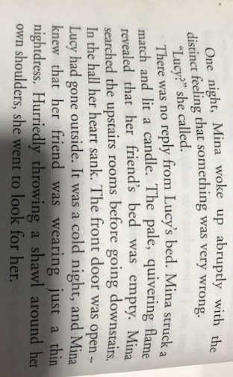
Find and Copy a word which is similar in meaning to ‘looked’.
___________________________________________________________________________
According to the text. Give two words which describe the light from Mina’s candle.
___________________________________________________________________________
According to the text which phrase tells the reader Mina is anxious about her friend.
___________________________________________________________________________
Find and copy a phrase which proves that Lucy is dressed inappropriately for the cold weather.
___________________________________________________________________________

Wednesday
Question Time
When is Mina searching for Lucy?
___________________________________________________________________________
Where does Mina see Lucy?
___________________________________________________________________________
What allowed Mina to see Lucy?
___________________________________________________________________________
Why is Mina concerned when she sees Lucy?
___________________________________________________________________________
What clues lets the reader know that the figure behind Lucy is evil?
___________________________________________________________________________
Why does Mina think she caused the wounds on Lucy’s neck?
___________________________________________________________________________
How does Mina try and protect Lucy?
___________________________________________________________________________
What is the significance of the bat at the window?
___________________________________________________________________________
Think about it!
What do we know has happened so far? Page 30 – 33. | What ideas do you have about what will happen.

