LI: To compare the life cycles of a mammal, an amphibian, an insect and a bird.
I will be successful if...
I can research and record key facts from each life cycle.
I can include scientific vocabulary in my writing.
I can compare at least 2 different life cycles stating similarities and differences.

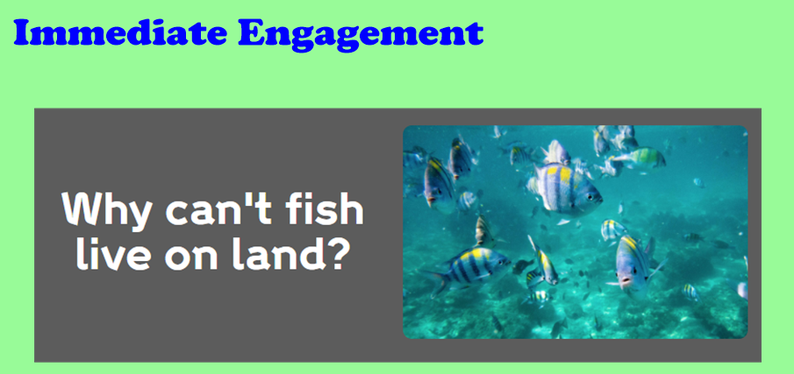

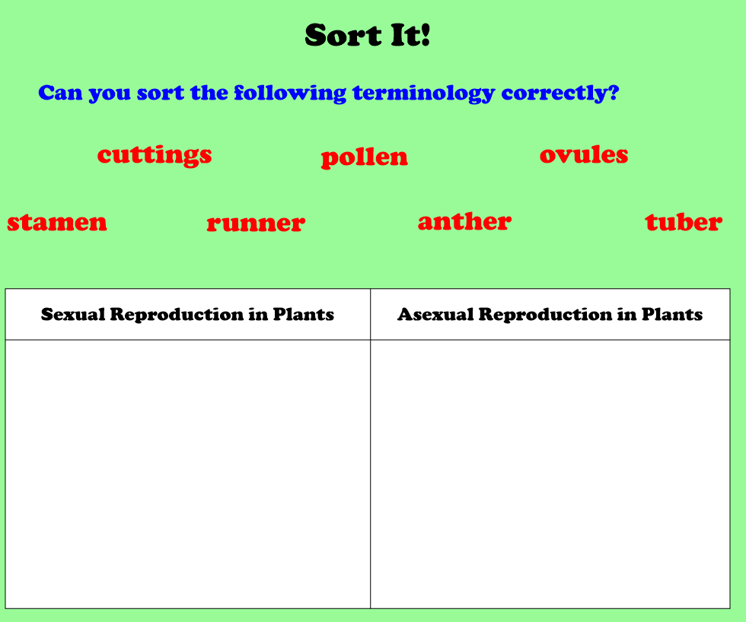

What I know already

Mammals:
Fish:
Reptiles:
Amphibians:
Birds:

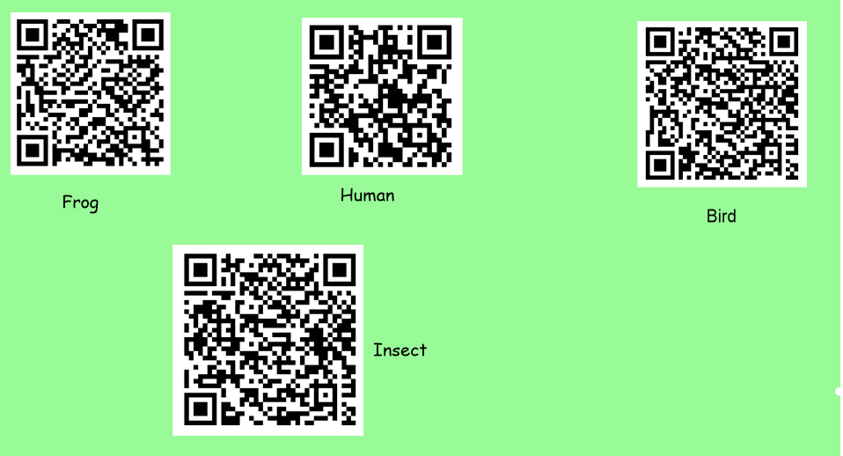
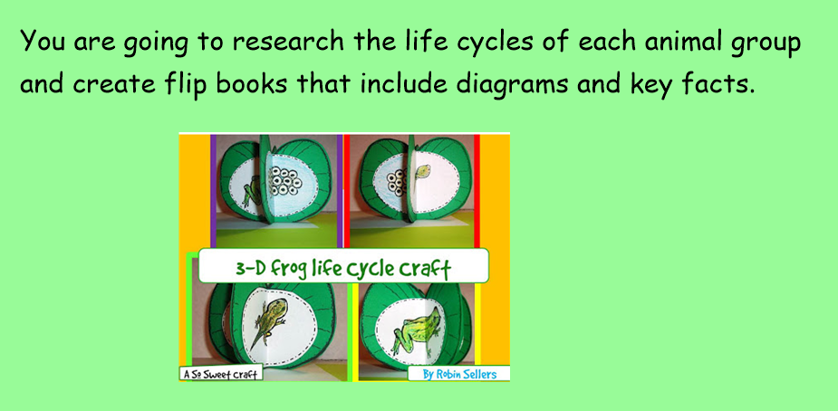

Comparison Grid
(picture)
(picture)

Only the reptile

Only the amphibian

They both

