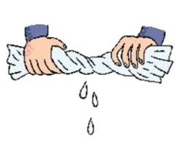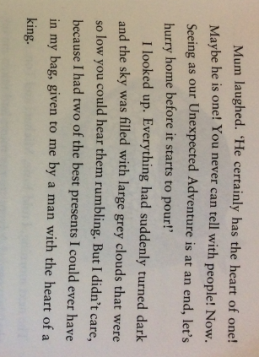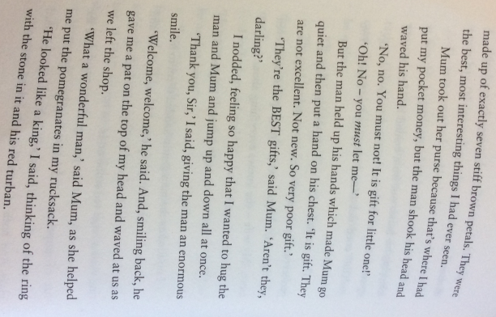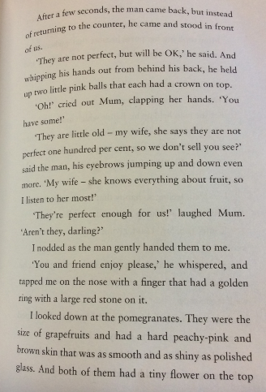

Wring It Out

2. Why does the man hold his hands up? What does this signify?

4. What does this tell us about the weather?

Why has the author used this phrase to help create the mood?

3. What does Mum mean when she says the man had a heart of a king?

1. Why does mum state that the pomegranates are perfect enough ‘for them’?