Tuesday 23rd February 2021
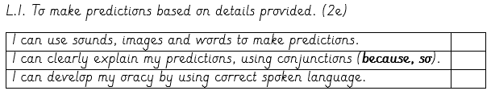

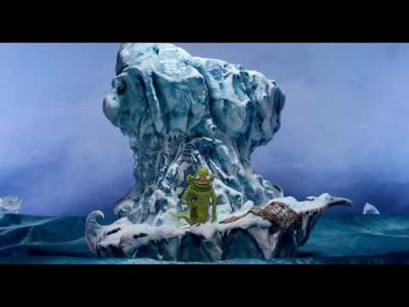
Sound on, Vision off
What clues can you hear for the characters, setting, plot?

Join our live learning to listen to the clip, or the link will be shared on Google Classroom.
Alternatively, you can find the clip by searching: FISHWITCH Trailer HD in YouTube

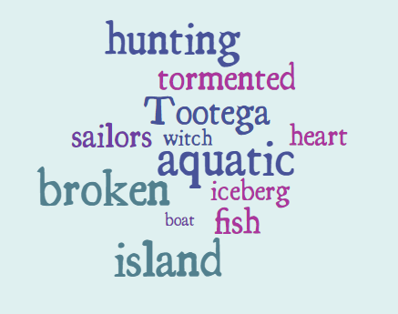
Our new text is called:
FishWitch

Based on the new evidence, I now predict that...

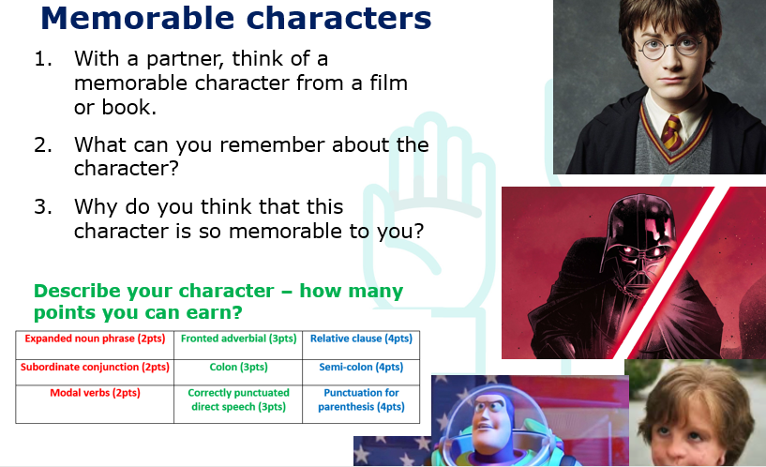

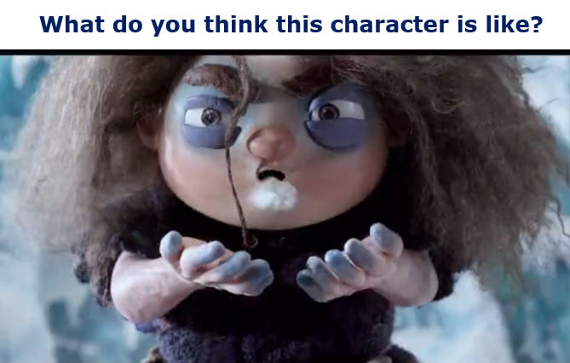

Skills check: Infer it (2d)
After watching the clip, fill in the boxes for what you notice about the character Tootega.
Action – what the character does or says | Impression – reasons why I think they act this way
Tootega grumbles at the start of the clip. | She is annoyed about something, possibly the cold or how tired she is, as she has big bags under eyes.

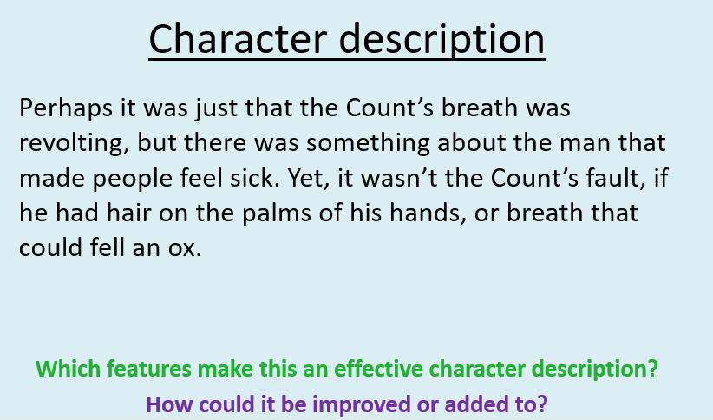

Now, write a character description of the witch – Tootega.

