Memory Recall - Summary
Wednesday 24th February 2021
Think back to the short clip of FishWitch we watched yesterday.
Describe what happened using the 5Ws:
- Who was involved?
- What can you remember happened?
- When did this happen?
- Where did it happen?
- Why do you think it happened?
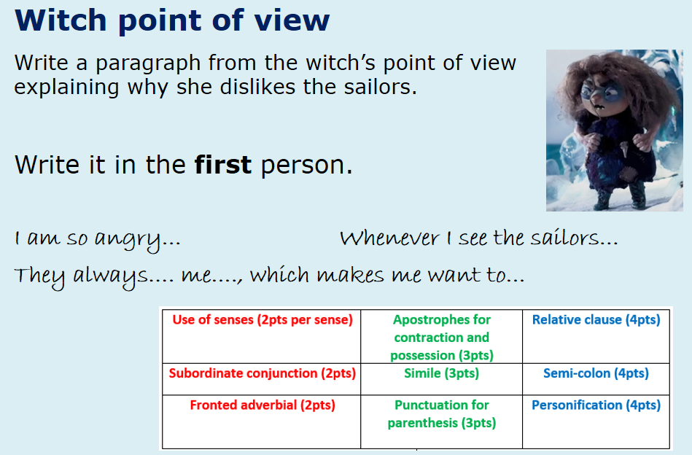

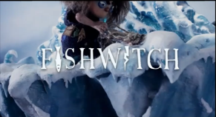
Join our live learning to watch the clip, or the link will be shared on Google Classroom.
Alternatively, you can find the clip by searching: FISHWITCH in YouTube – STOP at 1:18!

Can you see any similarities and differences between the two characters?
How do you predict that the two characters will react to one another when they meet?
Continuing watching, but STOP at 2:00!

Hot Seat!
What would ask these three characters that we have met so far?
Can you infer how they would reply?
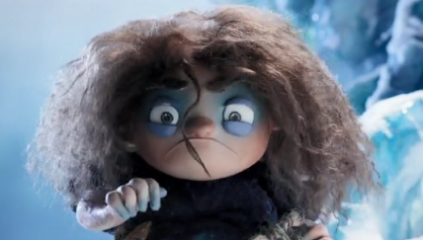
My Question:____________________________________
________________________________________________________________________________________________
Tootega’s Answer: _______________________________
________________________________________________________________________________________________________________________________________________________________________________________________

My Question:____________________________________
________________________________________________________________________________________________
Derek’s (merman) answer: ________________________
________________________________________________________________________________________________________________________________________________________________________________________________

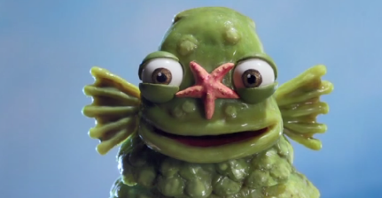

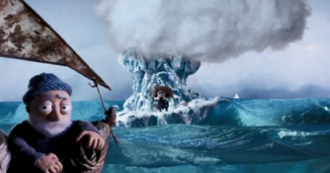
My Question:____________________________________
________________________________________________________________________________________________
Sailor’s Answer: _________________________________
________________________________________________________________________________________________________________________________________________________________________________________________

Now, imagine that you are the sailor who Tootega cast her spell on and saw Derek land on her iceberg. You need to produce an entry in the ship’s log to keep a record of what happened.

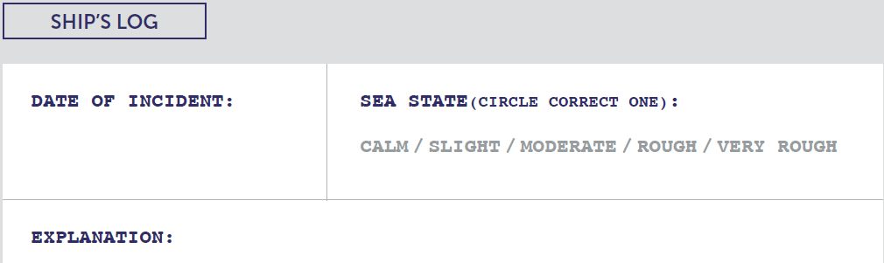

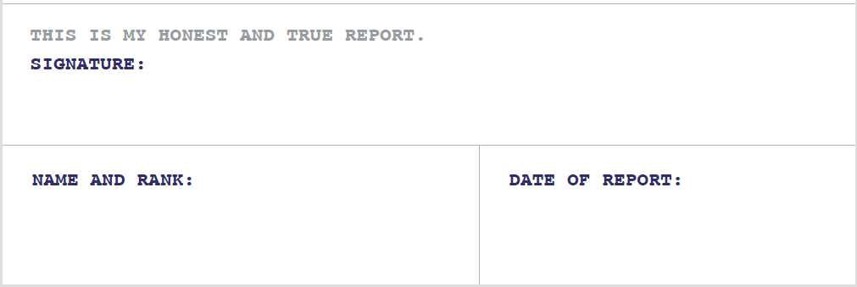
Checklist:
Write in the first-person (I). Use the past tense as it has already happened.
Give a report of what happened in chronological order (the order that they happened).
Use co-ordinating and subordinating conjunctions. Time adverbials (‘At first’, ‘then’, ‘next’ and ‘finally’).
Add adjectives and expanded noun phrases so that the reader can picture what happened more clearly.

