Thursday 25th February 2021
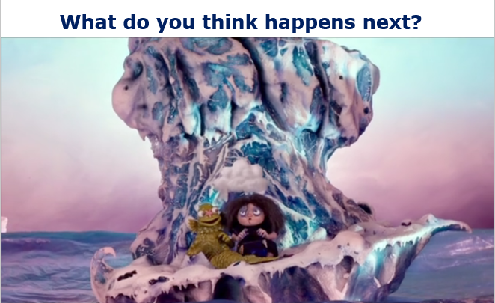

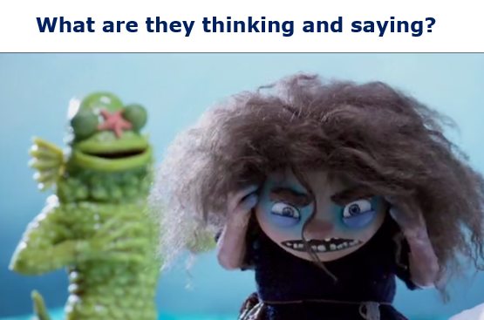

Join our live learning to watch the clip, or the link will be shared on Google Classroom.
You can find the clip by searching: FISHWITCH in YouTube – WATCH FROM 2:00 – 8:07!
As you watch, think about what Tootega should do next…

Decision Wheel – Content Domain 2b, 2d
Write four possible actions Tootega could take.
For each possible decision, what might the positive or negative consequences be?

What should Tootega do next?

Explain the decision you think Tootega should take.
Now, watch the rest of the film!
Write a review for the film. Would you recommend it to a friend?
Who was your favourite character? What was your least favourite scene in the film? Does it compare to any other films or books you know?

