Friday 25th February 2021

Yesterday, we watched the end of the FishWitch film.
SPEED WRITE!
Write down as many facts about the film as you can in 1 minute!

Today, we are going to plan what we think might happen next to Tootega and Derek.
Our plans are going to imagine events in film, and we are going to learn different types of camera shot to help us.

L.I:- To be able to recognise the different types of camera shots.
I will be successful if..
- I can recognise that there are 5 main shots.
- I can name the shots.
- I can explain why they are that particular shot.

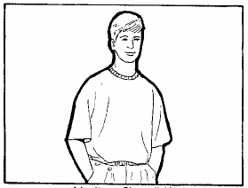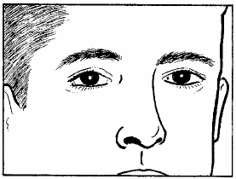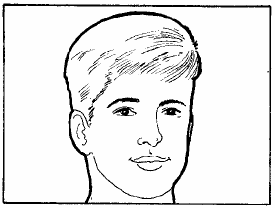

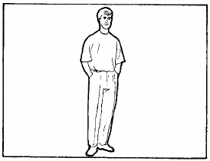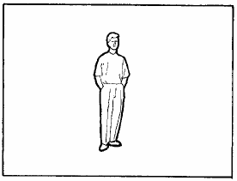

Match these with the appropriate camera shot name:
Medium shot Extreme close-up Close up Wide shot Long shot

Now, look at these stills from FishWitch. Match them to the appropriate camera shot type? Why has the film director used that shot?
How does it help show the character, setting or plot?

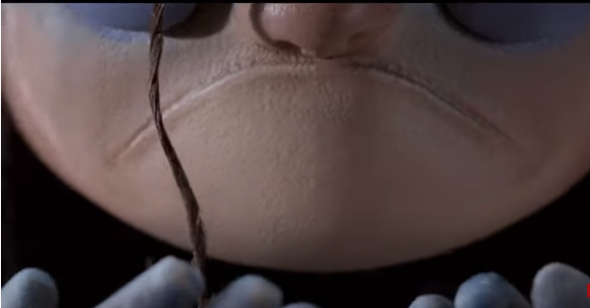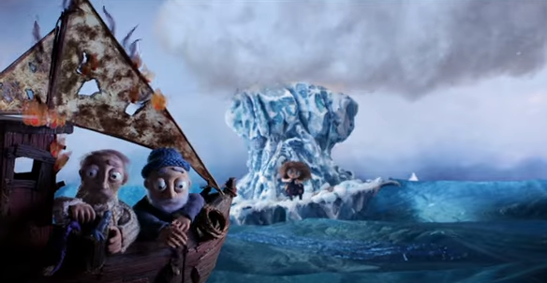

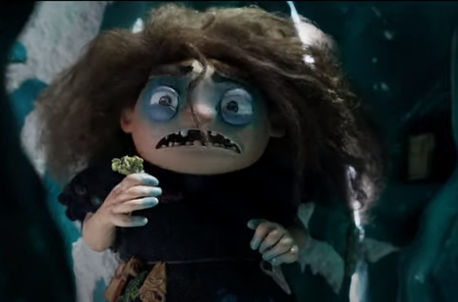
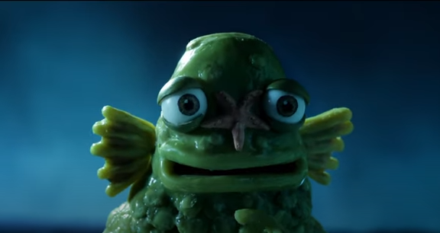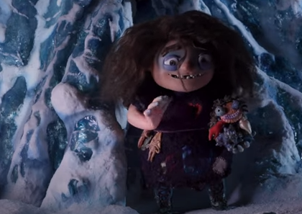

What happens next…? Summary
Before we can plan our own camera shots, we need to write a brief summary of what we think would happen next to Tootega and Derek.
For example: Tootega and Derek snuggled close to one another on the iceberg singing together. Suddenly...

