

**Monday 1st February 2021**

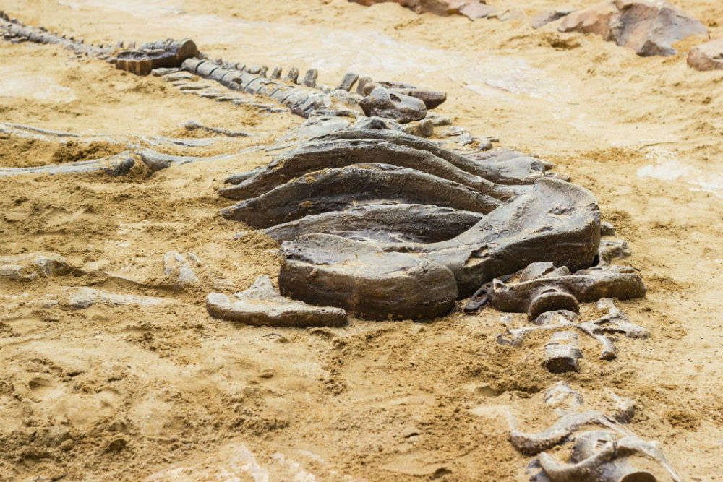

**The Argentinosaurus fossil was discovered after months of work by the world-leading palaeontologists.**

told us that measurements made estimated the weight of the Patagotitan was 50 tons, whereas the Argentinosaurus may have weighed a staggering 75 tons. Horner added, “There is a limit to how big animals can get, as the larger the life-form, the more its extreme energy needs are.”

How were these vast creatures able to survive? Logically - to grow and live – huge herbivores, which the Argentinosaurus were, needed to devour several trees daily just to stay alive. On the other hand, there were advantages to their size; no predators were able to attack them successfully. Dinosaur expert, Paul, explained, “Attempting to kill such a beast was useless for a relatively-small 20ft carnivore, despite their fearsome, razor-sharp teeth.”

At this early stage, it may be premature to suggest why the titanosaur became extinct. However, Dr Paul reasoned that it could be linked to a lack of sustainable food supplies: “It is possible that limitations in finding food are what limited the size of dinosaurs over time.” The American scientist also indicated that the sheer scale of the animals might have led to their downfall, because they would suffer, “problems with pumping blood all the way up to their heads, or structural issues regarding moving on land."

While research progresses and scientists continue to share their findings, there will be numerous questions to answer about the Jurassic giant. Staff at the site have confirmed that they will be updating the media and general public with further updates of their ground-breaking discovery.

Meanwhile, enjoy more detailed coverage of this news by accessing our online content, some of which will be featured in tomorrow’s edition.

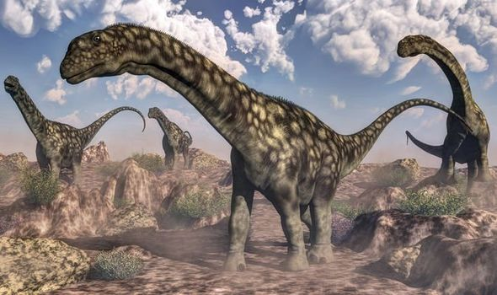

**3D model reconstructions of the Argentinosaurus suggest it would have been able to walk in a similar way to modern-day elephants.**

**Yesterday - following months of meticulous research and digging - dinosaur fossils were unearthed in South America. It has been suggested that the palaeontologists, who are based at an excavation site in Argentina, have discovered fossils belonging to the largest land animal that has ever been found by scientists. Reports indicate that the finding will transform our view of Jurassic species.**

Whilst only fragments remain of the dinosaur’s skeletons for scientists to use for testing, new evidence indicates there once existed a dinosaur that would have dwarfed even the tyrannosaurus-rex (often known as T-Rex). Unofficially named 'titanosaur', the Argentinosaurus roamed the world from the Jurassic through the mid-late Cretaceous, approximately 100 million years ago.

According to leading palaeontologist, Dr Gregory Paul, it is indisputable that this species of dinosaur is larger than the Patagotitan, which was recently believed to be the prehistoric heavyweight. Speaking exclusively, Paul confirmed, “My analysis is that Patagotitan is definitely not the largest known titanosaur; the previously less-known Argentinosaurus has individual bones distinctly larger in critical dimensions.”

Despite his remarkable discovery, Paul has openly conceded that there is a significant possibility, that there may even have once been something else even larger than them both: “It is not known what the maximum size limit of animals is on land or in the water, or indeed why these species adapted to such gargantuan sizes.”

Even though the dinosaur remains that have been found are incomplete, scientists insist that their findings and measurements are reliable. Highly-accurate models (constructed in 3D) were based on restorations of the entire skeletal profile of the dinosaur. As a comparison, Jack Horner

**DINOSAUR DISCOVERY!**

**Fossils found may have belonged to largest land animal!**