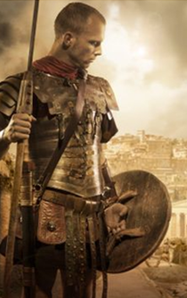
Li: to be able to imitate a poem
I will be successful if:
- I can explain what the poem is about
- I can recall key words and phrases
- I can replace words and phrases with my own
- I can make choices about my own work.
In the blanks add in your own words to complete the poem.
I am a Roman Soldier
I am a Roman soldier
I fight for ___________________ and for Rome
Our army is _____________________ and _____________________
We rule the _________________ with ______________ and ________________

I am a Roman soldier
The _______________ sun gleams off our _______________ shields
Our ________________ swords ________________ at our sides

I am a Roman soldier
__________________________ from home

I am Roman soldier

