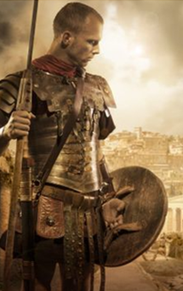
Li: to be able to imitate a poem
I will be successful if:
- I can explain what the poem is about
- I can recall key words and phrases
- I can replace words and phrases with my own
- I can make choices about my own work.
Write your own poem about a Roman Soldier.

____________________________________________________________________________________________________________________________________________________________________________________________________________________________________________________________________________________________________________________________________________________________________________________________________________________________________________________________________________________________________________________________________________________________________________________________________________________________________________________________________________________________________________________________________________________________________________________________________________________________________________________________________________________________________________________________________________________________________________________________________________________________________________________________________________________________________________________________________________________________________________________________________________________________________________

