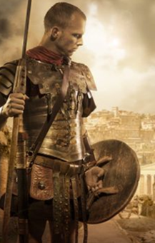

Roman Soldier Word Bank

Vicious | Ferocious | Pride | Bang | Flash
Sinister | Fearsome | Proud | Crash | Twinkle
Cruel | Strong | Joy | Beat | Ominous
Shimmer | Powerful | Satisfaction | Bounce | Harsh
Glisten | Wonder | Power | Gleaming | Unforgiving
Violent | Majestic | Danger | Twinkling | Glinting
Dangerous | Beauty | Sparkle | Glittering | Magnificent
Menacing | Splendour | Thud | Dazzling | Glorious

