Li: to be able to visualise a piece of text
I will be successful if:
- I can explain what the poem is about
- I can recall key words
- I can describe the image it conjures
- I can make choices on how to present my image
Draw an image and annotate with words and lines from
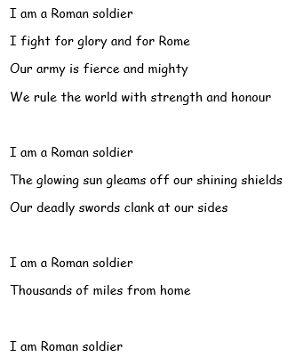
the poem.

