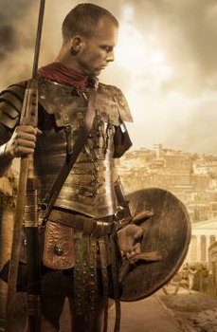
Li: to be able to understand a poem
I will be successful if:

- I can explain what the poem is about
- I can explain the vocabulary
- I can give my own opinion
- I can infer meaning
Find the 3 adjectives

Find the 2 verbs
Why is the line I am a Roman soldier repeated?

How is the character feeling at this point and why?

I am a Roman Soldier

I am a Roman soldier
I fight for glory and for Rome
Our army is fierce and mighty
We rule the world with strength and honour

I am a Roman soldier
The glowing sun gleams off our shining shields
Our deadly swords clank at our sides

I am a Roman soldier
Thousands of miles from home

I am Roman soldier

