Friday 12th February
Li: to be able to write an extended piece of writing
I will be successful if:
- I can use full stops and capital letters
- I can use the coordinating conjunction and
- I can use adjectives
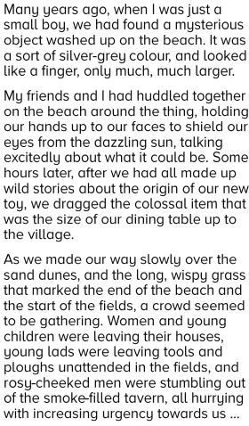
- I can use verbs

