Thursday 11th February
Li: to be able to write a descriptive information section for an information leaflet
I will be successful if:
- I can recall key information
- I can use coordinating conjunctions
- I can use adjectives
- I can use question marks
The Parthenon
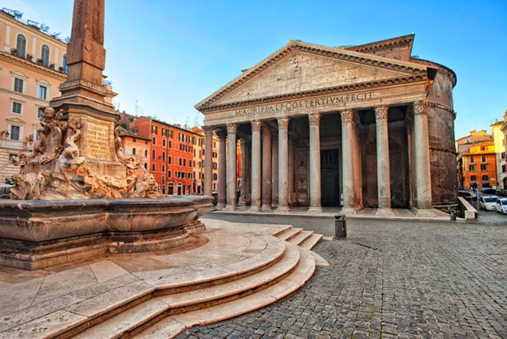
Do you want to be awestruck? Do you want to be left fascinated by the wonder of the Roman builders and engineers?
Then visit the Parthenon! This magnificent building has a golden roof! It glitters brightly in the hot Roman sun.
It is also covered in shining bronze tiles which shimmer majestically in the daylight.
Inside it is also a feast for the eyes. Stare in wonder at the 43-meter-high dome.
Marvel at the beautiful paintings and the glorious artwork which cover the walls and ceiling.
This building is the embodiment of Roman skill. It shows that our Roman builders are the best in the world.
Rewrite The Parthenon section in your own words
_______________________________________________________________________________________
_______________________________________________________________________________________
_______________________________________________________________________________________
_______________________________________________________________________________________
_______________________________________________________________________________________
_______________________________________________________________________________________
_______________________________________________________________________________________
_______________________________________________________________________________________
_______________________________________________________________________________________
_______________________________________________________________________________________
______________________________________________________________________________________

