Thursday 11th February
Li: to be able to write a descriptive information section for an information leaflet
I will be successful if:
- I can recall key information
- I can use coordinating conjunctions
- I can use adjectives
- I can use question marks
Overwrite: rewrite each line in your own words
The Parthenon
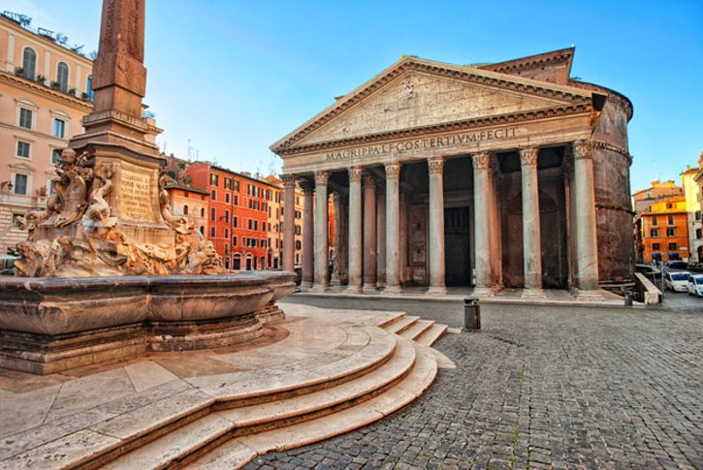
Do you want to be awestruck? Do you want to be left fascinated by the wonder of the Roman builders and engineers?
______________________________________________________________________________________
Then visit the Parthenon! This magnificent building has a golden roof! It glitters brightly in the hot Roman sun.
______________________________________________________________________________________
It is also covered in shining bronze tiles which shimmer majestically in the daylight.
______________________________________________________________________________________
Inside it is also a feast for the eyes. Stare in wonder at the 43-meter-high dome.
______________________________________________________________________________________
Marvel at the beautiful paintings and the glorious artwork which cover the walls and ceiling.
______________________________________________________________________________________
This building is the embodiment of Roman skill. It shows that our Roman builders are the best in the world.
______________________________________________________________________________________

