Friday 5th February 2021

What are the two types of speech used in newspaper reports?
In what ways are they the same/different?

Today, we are going to imitate the Dinosaur Discovery! newspaper report.

We can magpie key facts, the name and ideas from the scientists, but we need to use our own sentences and vocabulary to build the newspaper report.

This week, we have practised:
Introductory paragraph - 5Ws
Scientist quotes - reported / direct speech
Formal tone

Before we start writing our imitation, let's re-read the WAGOLL to see what the topic sentences are.

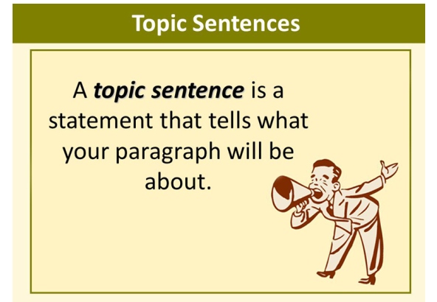

L.I. To imitate a newspaper report.
I can use and follow the structure of the newspaper report.
I can include key features (5Ws, formal tone, topic sentences).
I can include correctly punctuated direct speech for quotes.

You may use the blank newspaper template to write your report, or, if it is easier, write it on normal lined paper or type it.

