L.I:- To be able to apply problem-solving strategies.
I will be successful if..
- I can recall the 6 problem solving strategies.
- I can read and annotate the information.
- I can suggest how to break down the problem.

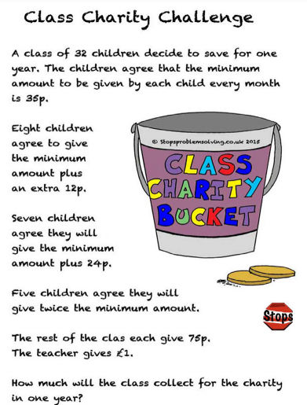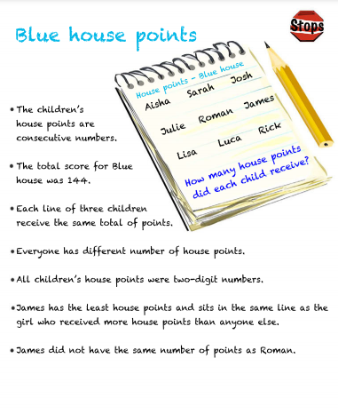
L.I:- To be able to apply problem-solving strategies.
I will be successful if..
- I can recall the 6 problem solving strategies.
- I can read and annotate the information.
- I can suggest how to break down the problem.

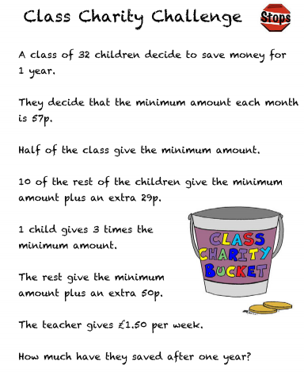

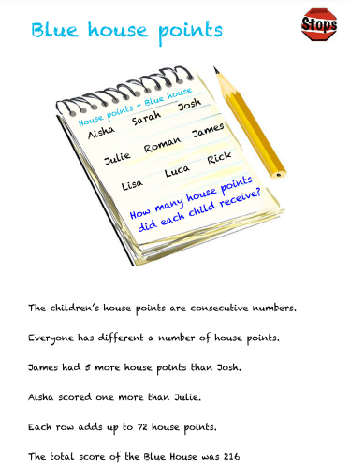

L.I:- To be able to apply problem-solving strategies.
I will be successful if..
- I can recall the 6 problem solving strategies.
- I can read and annotate the information.
- I can suggest how to break down the problem.

