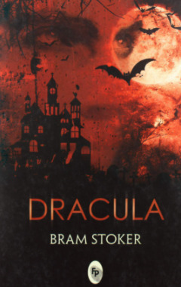
Friday
Guided reading
Can you complete a book review of the book Dracula?
Choose one of the characters and write an in depth report about their character and behaviours.
Would you recommend this book to a friend? Why?
You can create a power point, green screen, imovie or a written report to present your book review.

