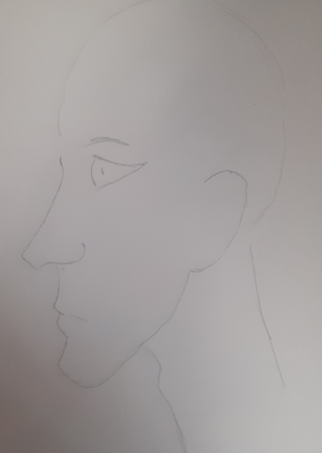
STAGE 1
Use profile sheet to sketch main details , notice shape of eye
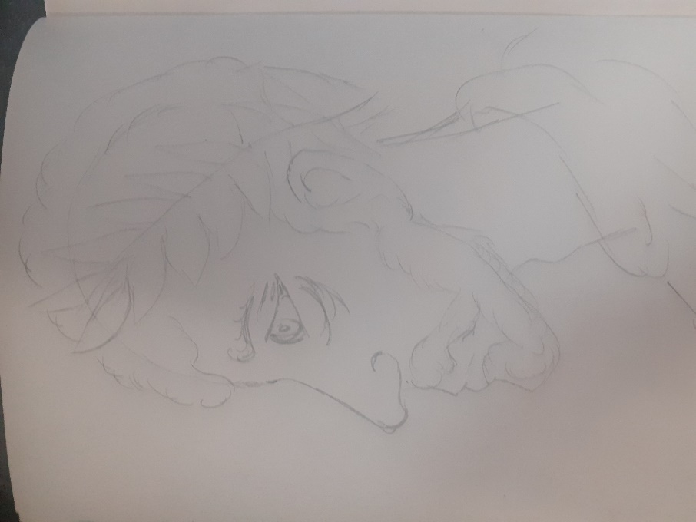
STAGE 2
Look at the picture of Hadrian and add detail
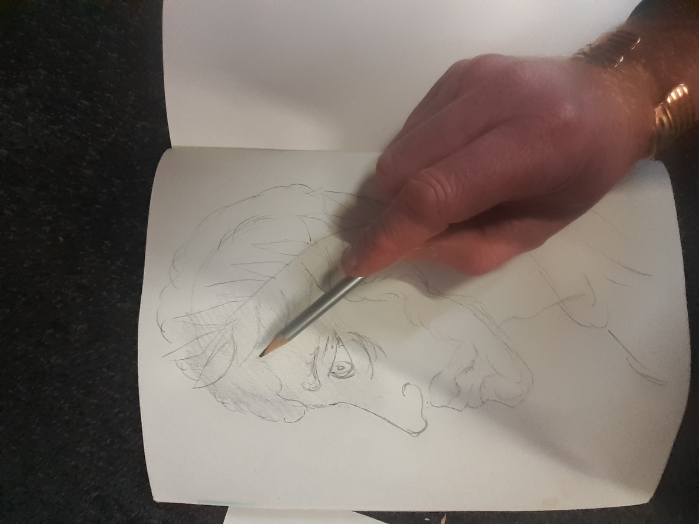
STAGE 3
Using side of pencil add a very light coat of HB to whole piece with exception of eye and toga

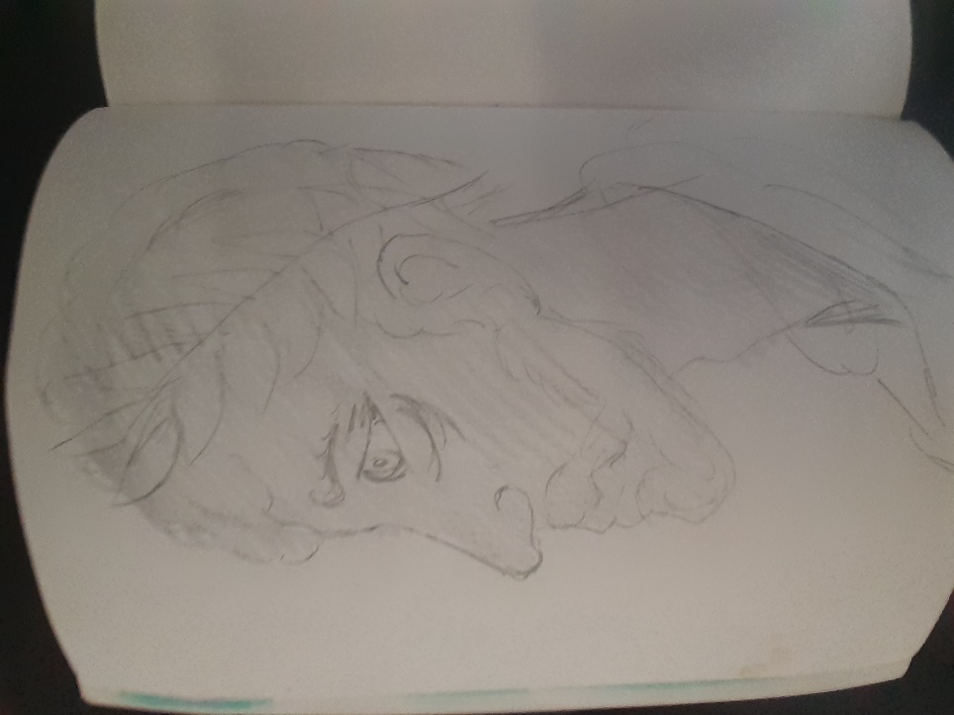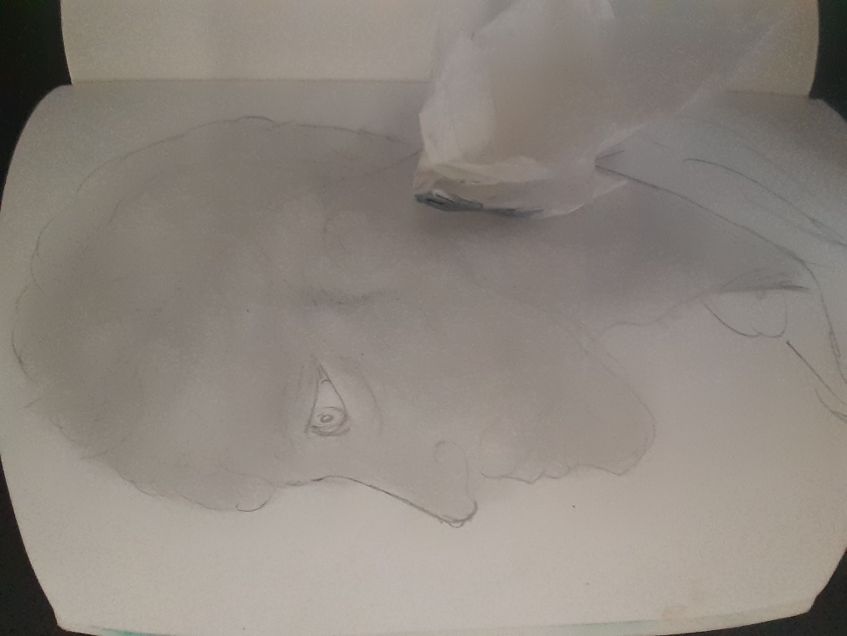
STAGE 4
When complete rub the pencil in with tissue in small circular motions
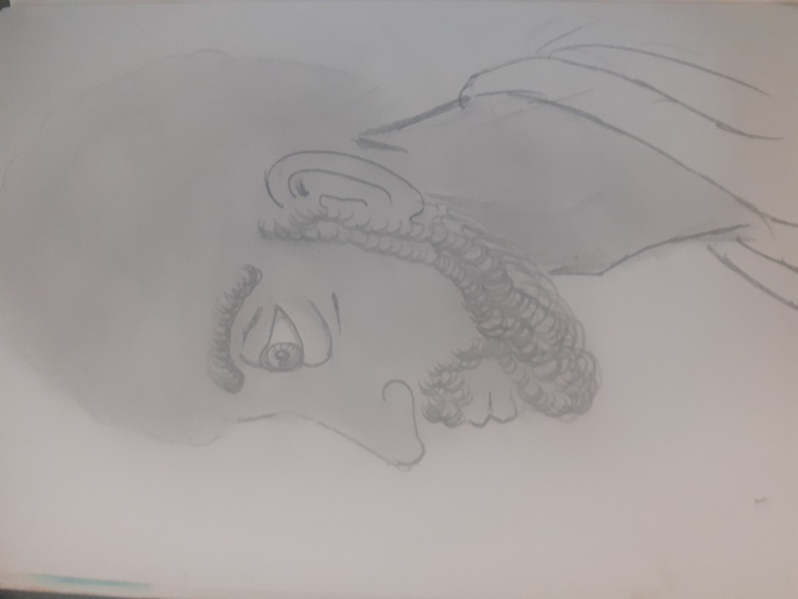
STAGE 5
Using a sharp pencil put on the beard in short curly movements
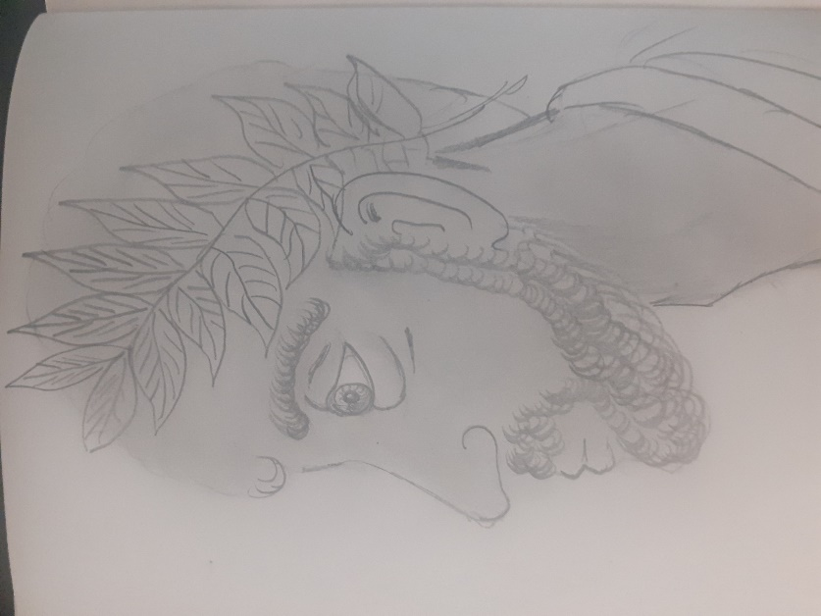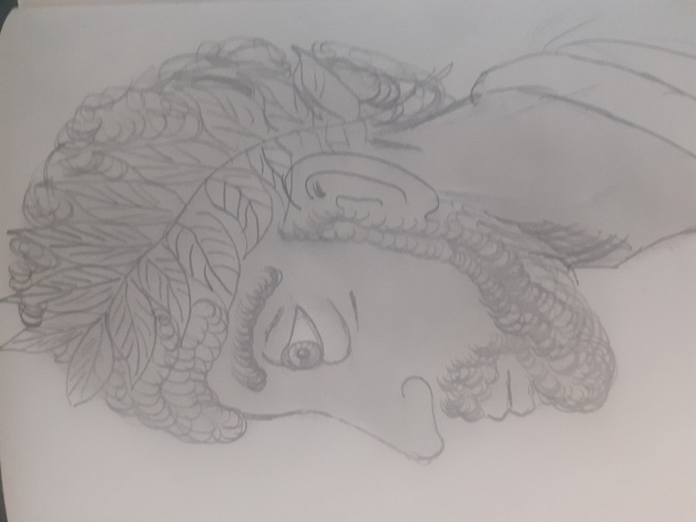
STAGE 6
Add the detail of the hair and laurel wreath in hair

