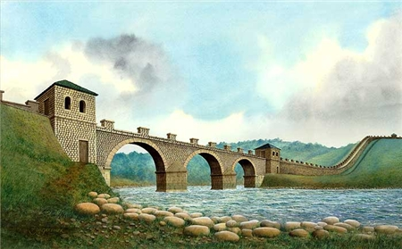

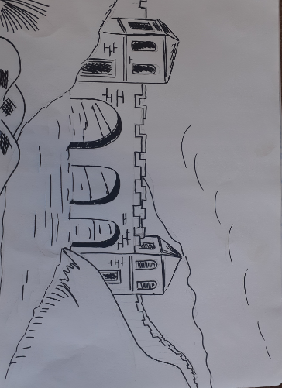
STAGE 1
Draw the main details lightly in HB pencil
Notice in this one I have simplified the picture a little
NOTE
This stage by stage is for watercolour pencil , if you only have colour pencil once you have sketched it colour sky then water , land and finally buildings
It is then you would add the detail in STAGE 2
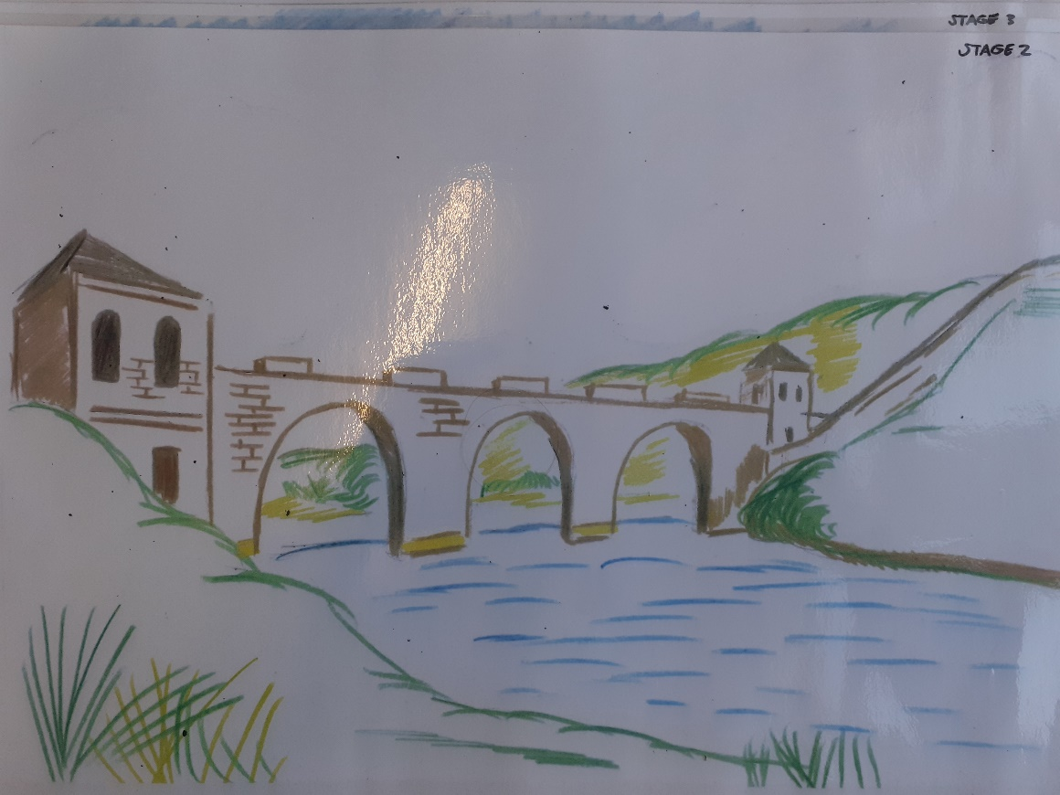
STAGE 2
Over your light pencil marks add the colours of the grass , water , stone . Don’t colour in full areas this is just detail
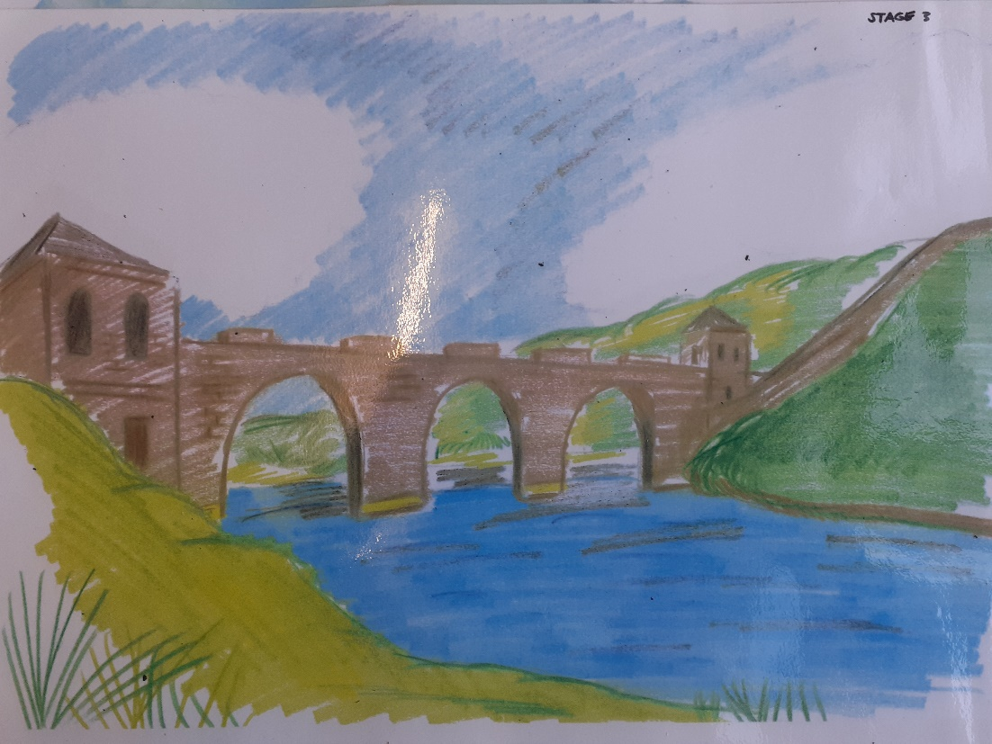
STAGE 3
Using watercolour pencils very lightly add the colours
DO NOT GO TO THE EDGE OF THE PAPER
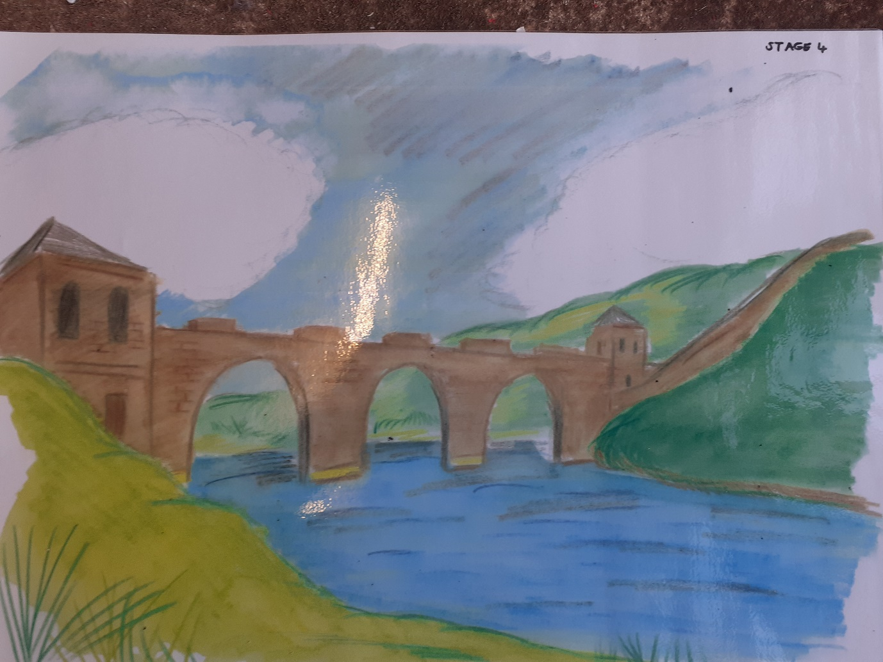
STAGE 4
Add the water with a medium size brush
You must go in this order
SKY – WATER – LAND – STONE

