Homework Project – Year 6
As part of our learning about Whitby, we have so far looked at the novel Dracula and coastal erosion. In Spring 2, we are going research Whitby’s history, including the life and importance of Captain Cook.
We would like you to: create a 3D model or piece of art of Captain Cook’s ship: HMS Endeavour.
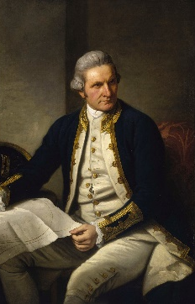
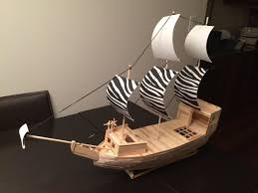
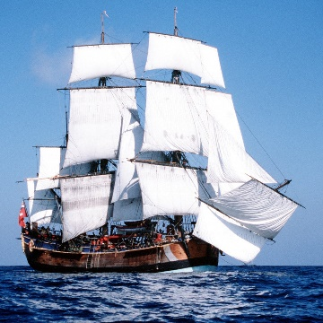
You could use:
- Lego
- 3d modelling/junk modelling
- Cardboard
- Drawing/painting
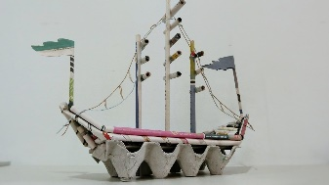
- Clay/salt-dough
- Matchsticks/jigsaw/wood

If you complete your project, you will receive 5 dojo points!
Homework menu
Complete the Maths learning shared on Classroom – this will help you to remember how to find percentages of amounts and interpret graphs. | Complete a book review – What you did enjoy and why? Would you recommend this book to a friend? Share a video of you reading your review or favourite part of the book. | Our Science unit for this half term is going to be Electricity!  Research the history of electricity, how lightning is formed, create a model of a working electrical circuit and complete a (safe) electric project / experiment (links for this will be available on Dojo and Classroom).
Research Captain Cook? Who was he? Why was he important? How is he relevant to Whitby?  Practice your formal writing skills to complete a report about Captain Cook – you could even record it and use green screen!  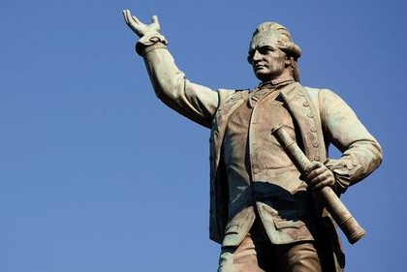 | After the snow during Spring 1, we have no idea what weather half term will bring!  We’d love to see how you enjoy the great outdoors during your week off. Take photos of the nature you experience, draw the scenes you see, compose some creative writing. | What is weaving?  Why is it relevant to Bradford?  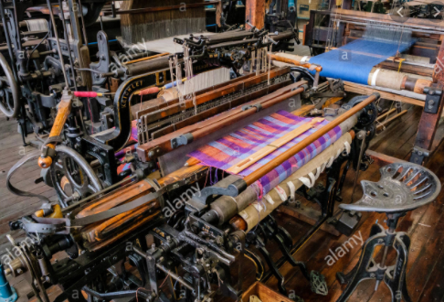  Use paper or wool to create your own weaving project ahead of our hook day!

Hook day – Monday 15th February 2021.
We will start our new half term with a day of weaving!
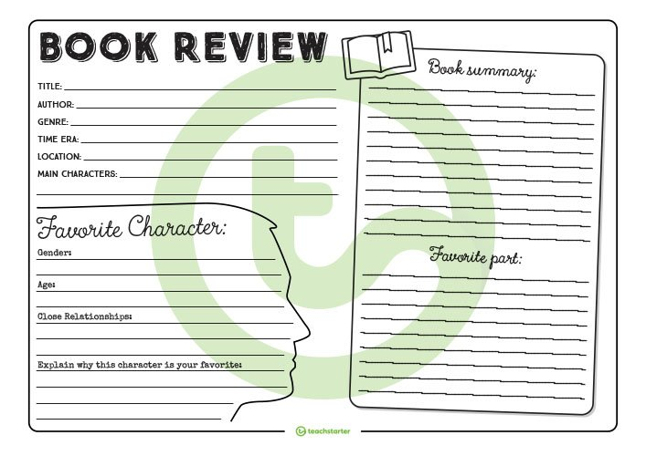
Year 5 and 6 spelling words.
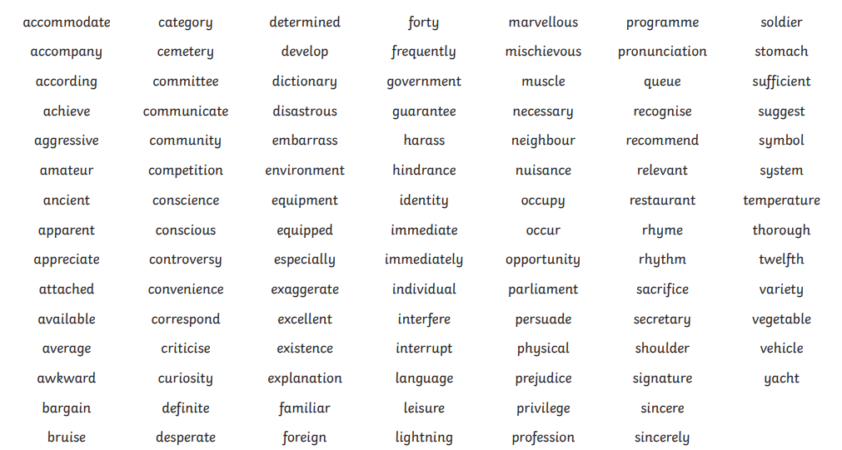
After an unusual half term, we hope you have a peaceful and relaxing week’s break. Thank you for your hard work during home learning.
Best wishes from Mrs Allingham, Mr Brownsell and all of the year 6 team.

