Hook Day Monday
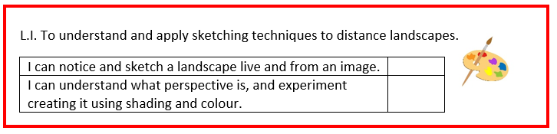

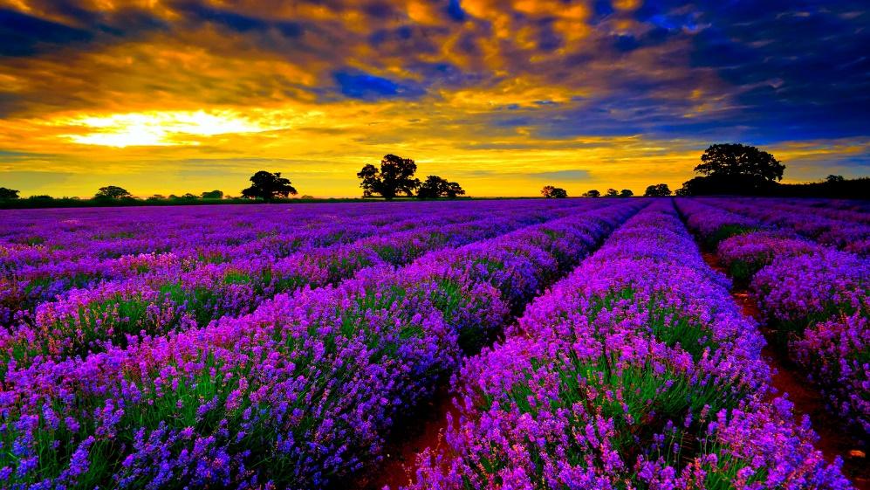
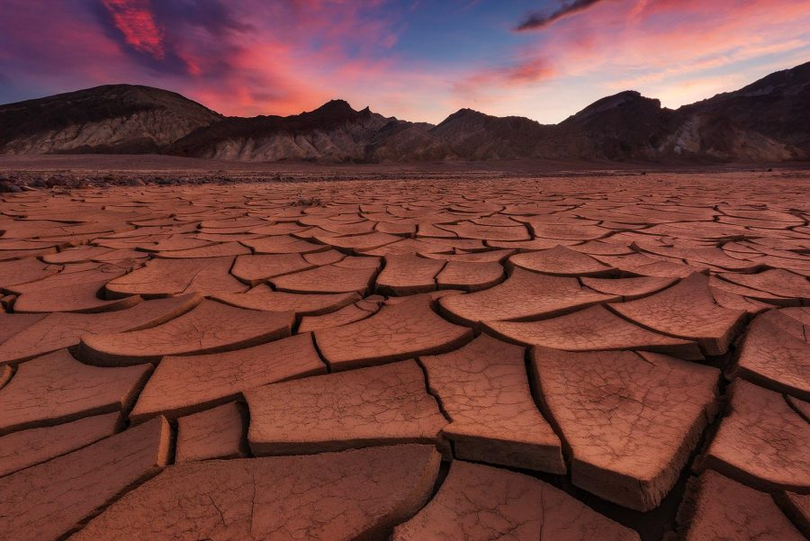
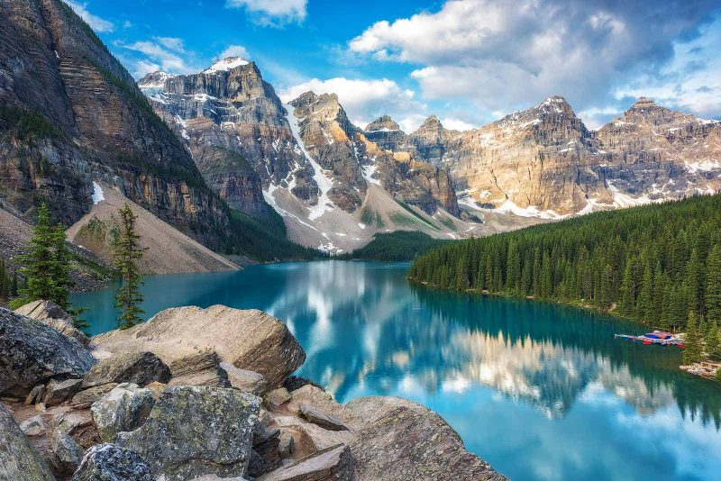
Can you compare the different landscapes? What is similar and what is different?

Similar | Different

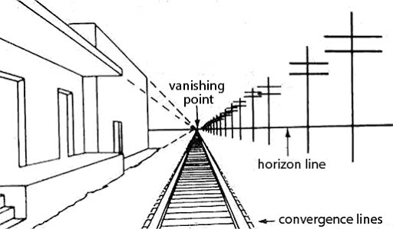
Can you explain what perspective means and how it is used?

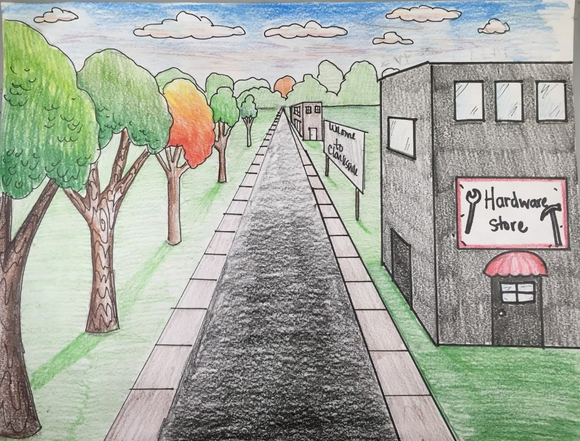
How has perspective been used here?

Can you design your own perspective picture?

