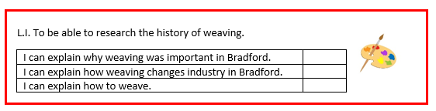

Lesson 2

Memory recall
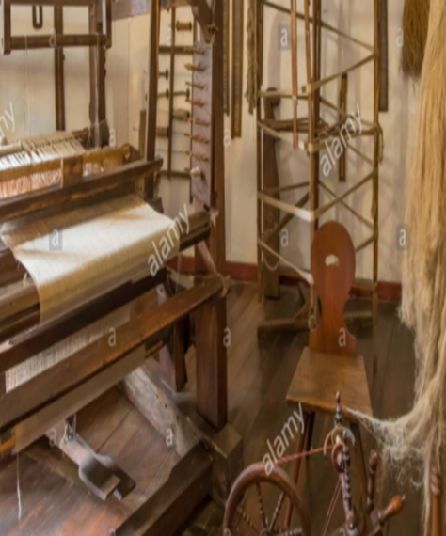
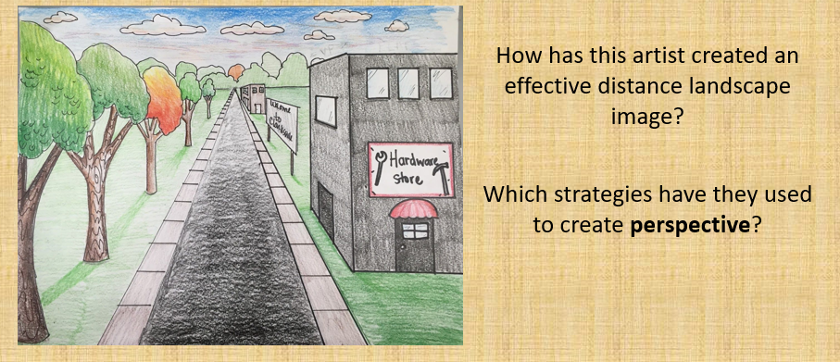

https://www.youtube.com/watch?v=9OHbJQ90hfY
Watch the you tube video – What can you explain about the history of weaving?

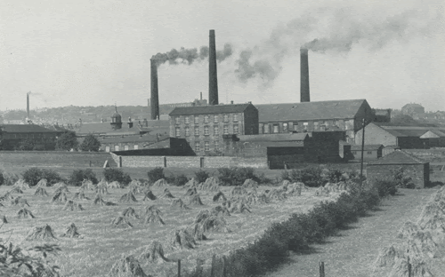
Why is weaving important to the history of Bradford?
https://www.visitbradford.com/history-of-bradford.aspx

At the turn of the 19th Century, Bradford was a small rural market town of 16,000 people, where wool spinning and cloth weaving was carried out in local cottages and farms.
By 1841 there were 38 worsted mills in Bradford town and 70 in the borough and it was estimated that two-thirds of the country's wool production was processed in Bradford. Less than ten years later, Bradford had become the wool capital of the world with a population of 100,000 leading to the development of a solid engineering and manufacturing base and a key financial centre which has continued to flourish ever since.
Industrial growth led to the rapid expansion of the city. Between 1800 and 1850 Bradford changed from a rural town amongst the woods and fields to a sprawling town filling the valley sides. The town centre expanded and its old buildings were largely replaced by new ones with lavish Victorian architecture still much in evidence today. Bradford was granted city status on 9 June 1897 and became a metropolitan district council in 1974.
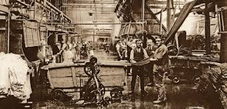
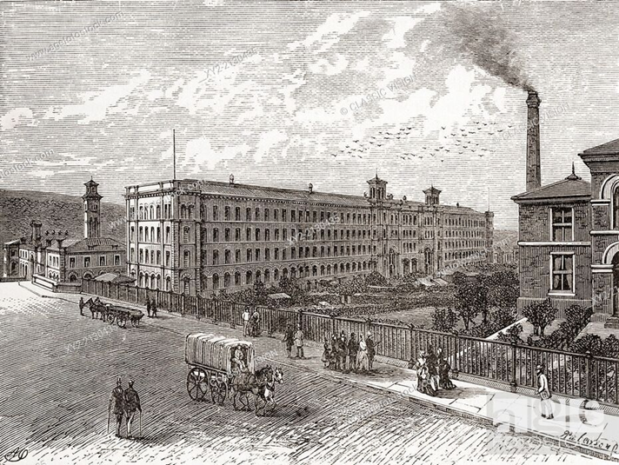
Can you recall 5 key facts about the history of weaving in Bradford?

Create a double page spread using a range of presentation features to capture the history of weaving in Bradford.

