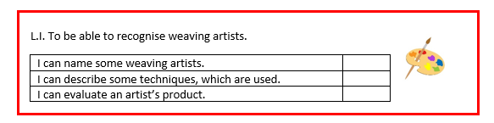
Lesson 3

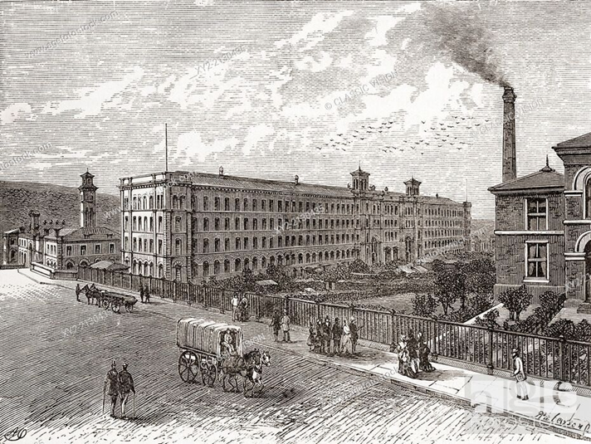
Memory recall – What was weaving important in Bradford?

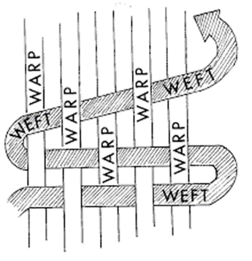
What do you know about this image?

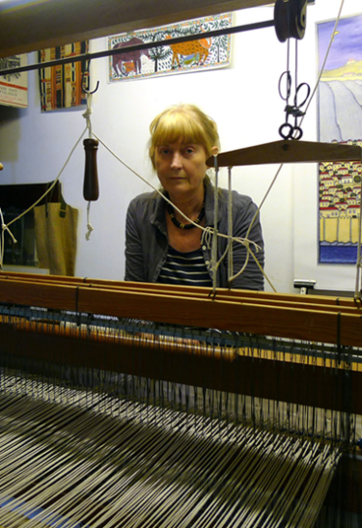
What does a weaver do?

Sue Spooner is a tapestry maker and weaver based in Cornwall, England. Her vivid designs draw their imagery from the built landscape, ancient and historic, where deserted buildings have undergone a process of decay, coloured with rust or corroded by the course of time.

