Tuesday 23rd February 2021

Write a Rags to Riches story where the main character has to move from their home.
Things we learnt last half term that you should try include:
- Expanded noun phrases
- ISPACE sentence starters
- Show not tell
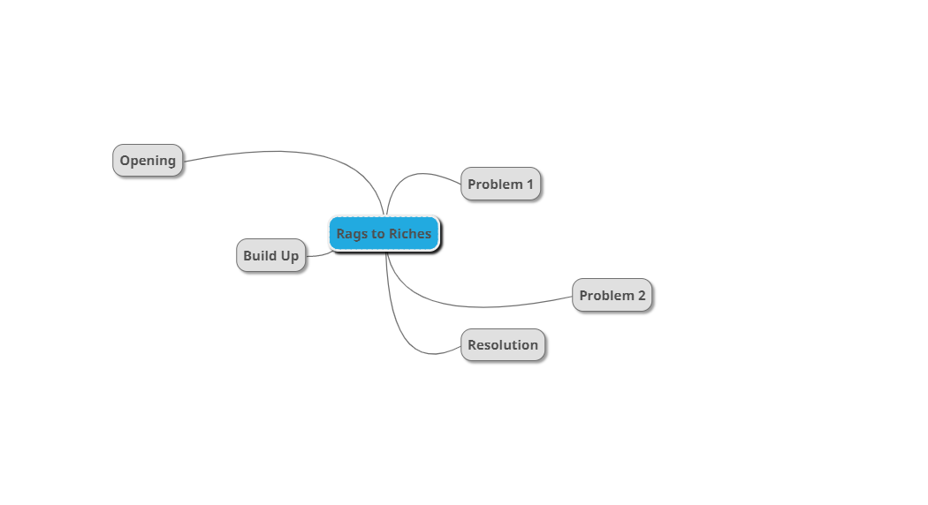
- Main Clause and Subordinate Clause
- Relative clause – using a relative pronoun
- Emotive Language

