History/ICT wc: 8.02.21
Recap of History facts:
Read these facts to refresh your mind:
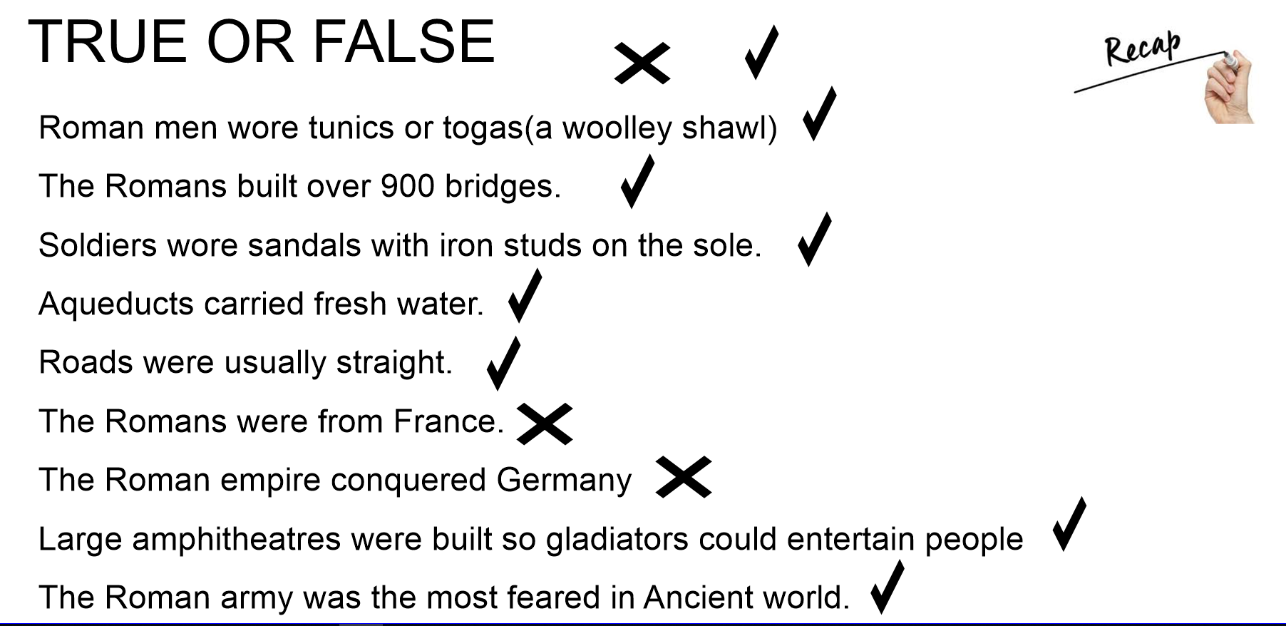

Use the venn diagram to compare life in Roman times and now: What is the same? What is different?

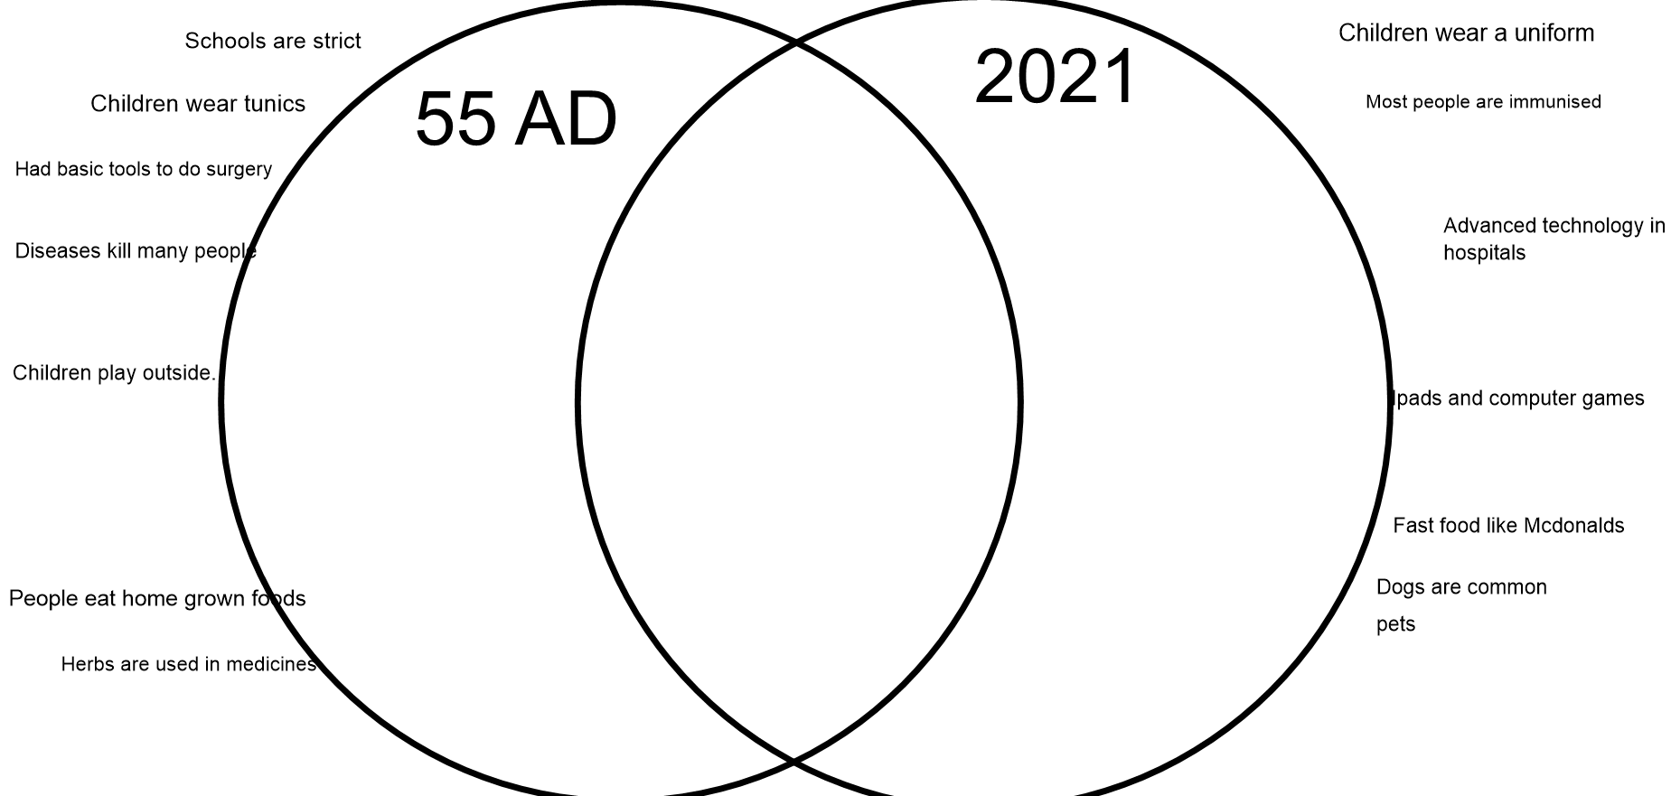

Word of the day:
Use powerpoint to create an information presentation about life for children now and in the Roman times:
