Wednesday 24th February
Instructions – Non-unit fractions of amounts (word problems)

You may want to read the instructions for the modified fraction activity before you read these, to remind yourself of previous fractions work. The loom video for this work follows on from the loom video for the modified activity too.
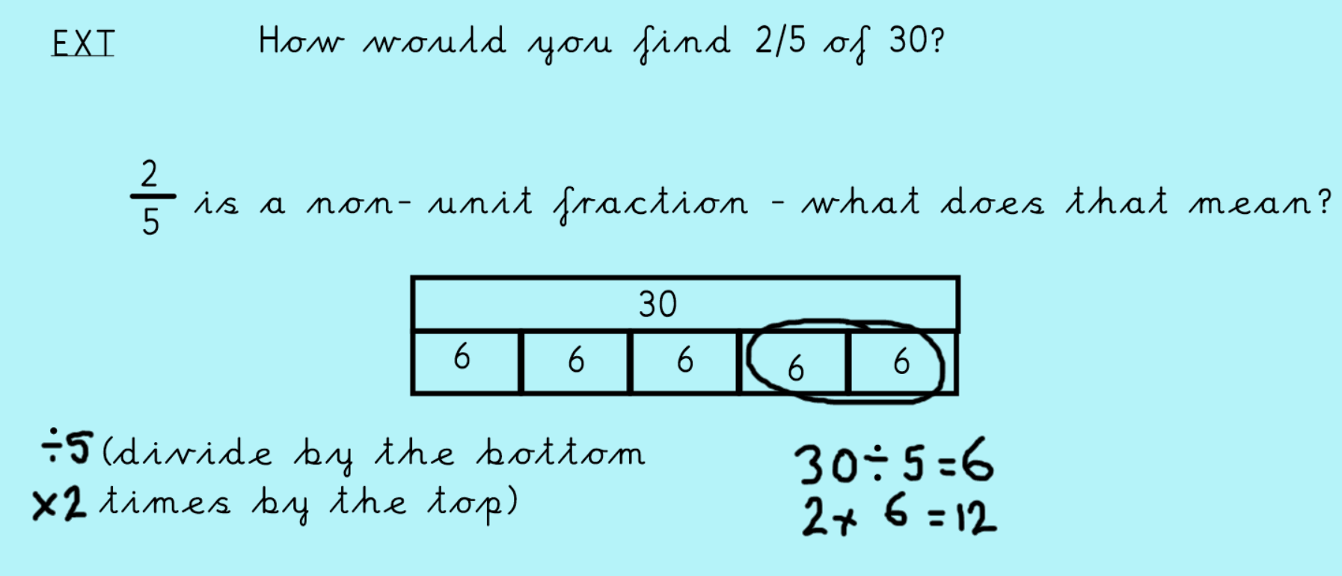
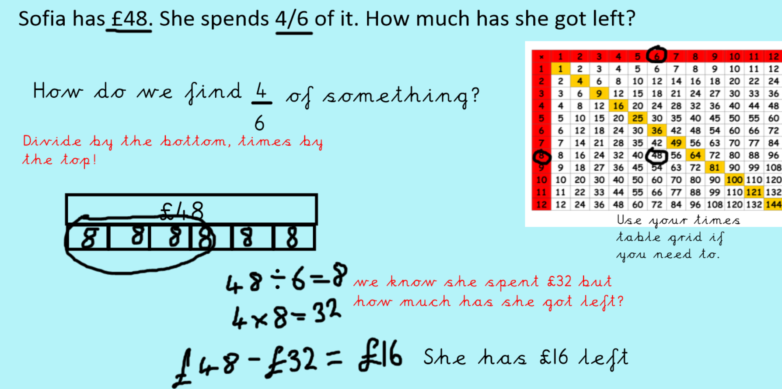
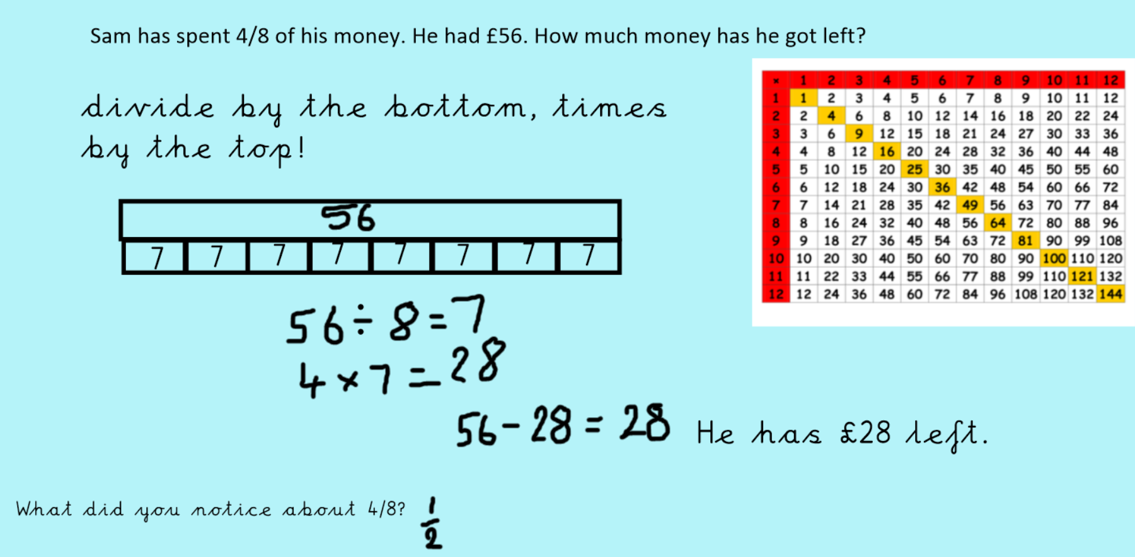
Now have a go at the fraction task. If you need help, please watch the video or ask on dojo or classroom. We will go through this in live lessons too.

