The Glories of Rome
Introduction:
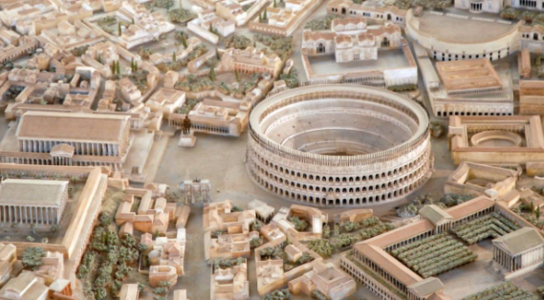
Do you want to see the most amazing city in the world? Then come to Rome!
The magnificent city of Rome is the centre of the mighty Roman Empire.
In this great city our glorious emperor leads his citizens with honour and strength.
Our city was founded by the celebrated leader: Romulus. He decided to build this great city in honour of the gods.
He wanted to create the most powerful and beautiful city in the world and so he did.
On your visit to Rome you might want to check out these fantastic places.

The Colosseum
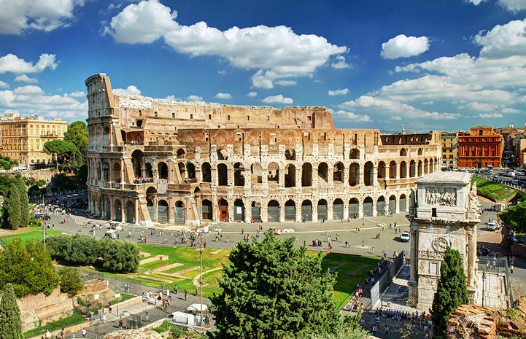
Welcome to the Empire’s biggest and best amphitheatre. This colossal building can seat 50,000 people.
Come and watch the fearsome and vicious gladiators battle to the death. Who will win?
Will it be the heavily armoured Provocator with his deadly sword?
Or will it be the quick and nimble Retiarius with his net and spear?
You may even get to see wild and exotic animals from across the Empire challenge these fierce fighters.
In this blood covered arena you will be entertained and thrilled by the battles which take place and best off all it is free!

The Forum
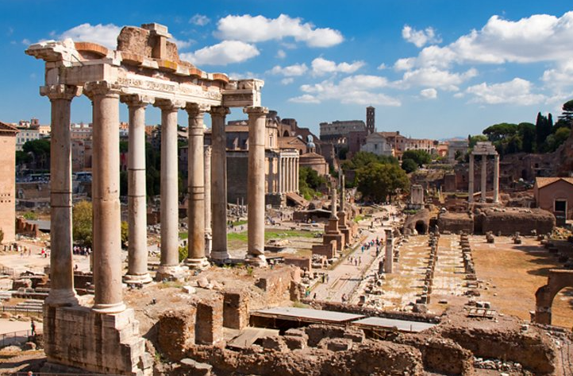
Visit the very centre of Rome. In this place you will be at the heart of government, law and business.
This is this place where the fate of the Empire was decided. Rules and laws were created here and passed onto the rest of the world.
Not only would you come here to make history. You would come to the Forum to enjoy the bustling and busy markets.
In these colourful markets stall you can buy everything you need and want from fish to fabric.
Whilst here why not say a pray to our wonderful gods? You could visit one of the many temples and leave a gift for your favourite god.

The Parthenon
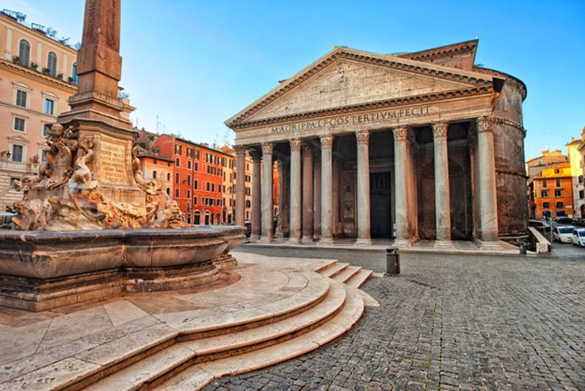
Do you want to be awestruck? Do you want to be left fascinated by the wonder of the Roman builders and engineers?
Then visit the Parthenon! This magnificent building has a golden roof! It glitters brightly in the hot Roman sun.
It is also covered in shining bronze tiles which shimmer majestically in the daylight.
Inside it is also a feast for the eyes. Stare in wonder at the 43-meter-high dome.
Marvel at the beautiful paintings and the glorious artwork which cover the walls and ceiling.
This building is the embodiment of Roman skill. It shows that our Roman builders are the best in the world.

Are you ready to visit Rome?

