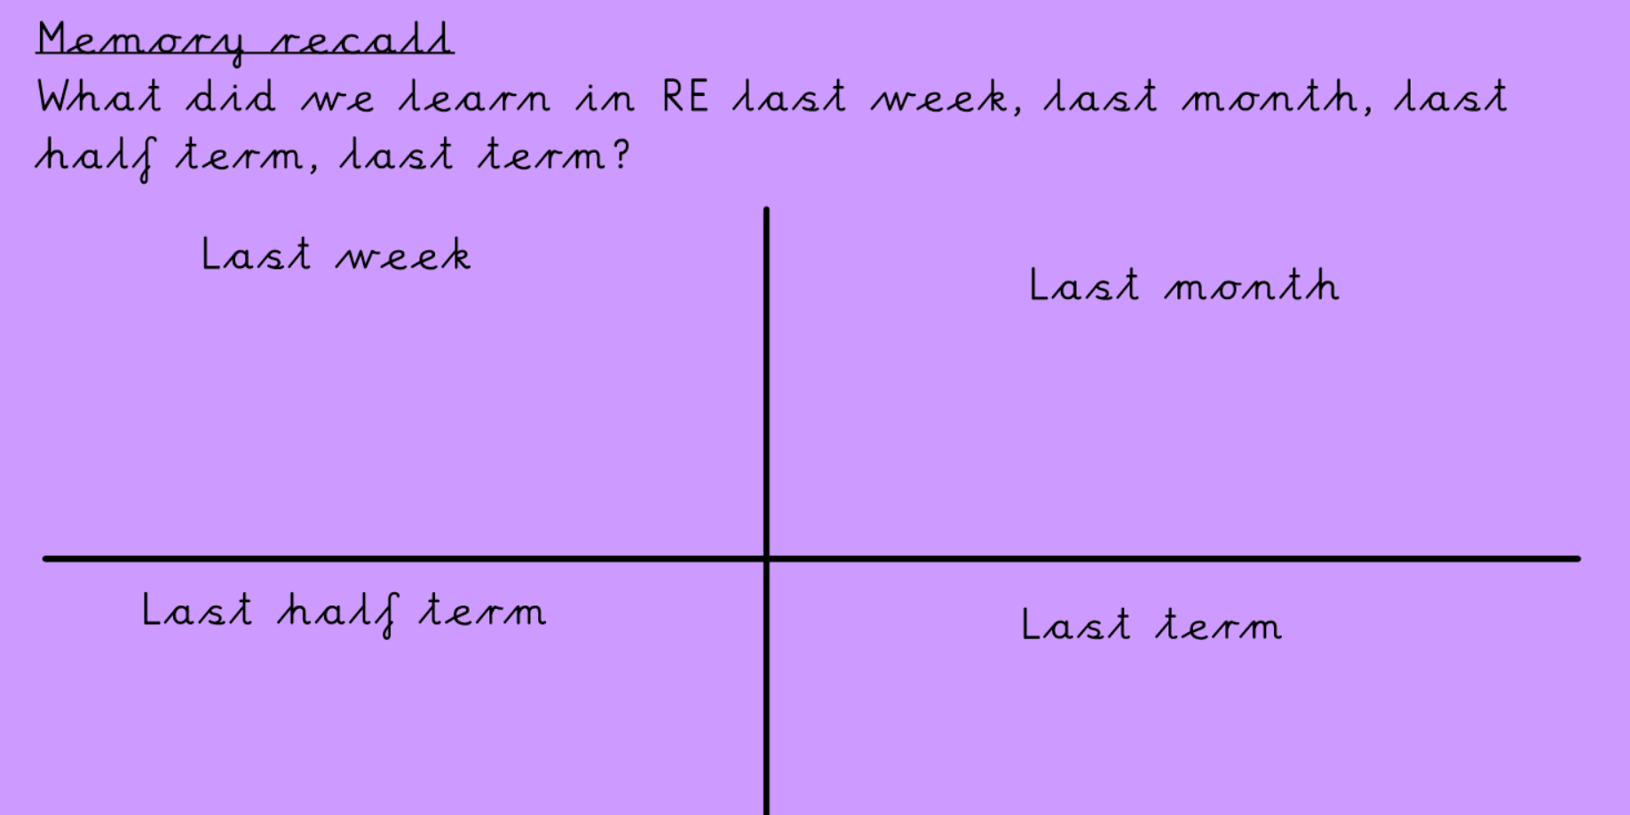

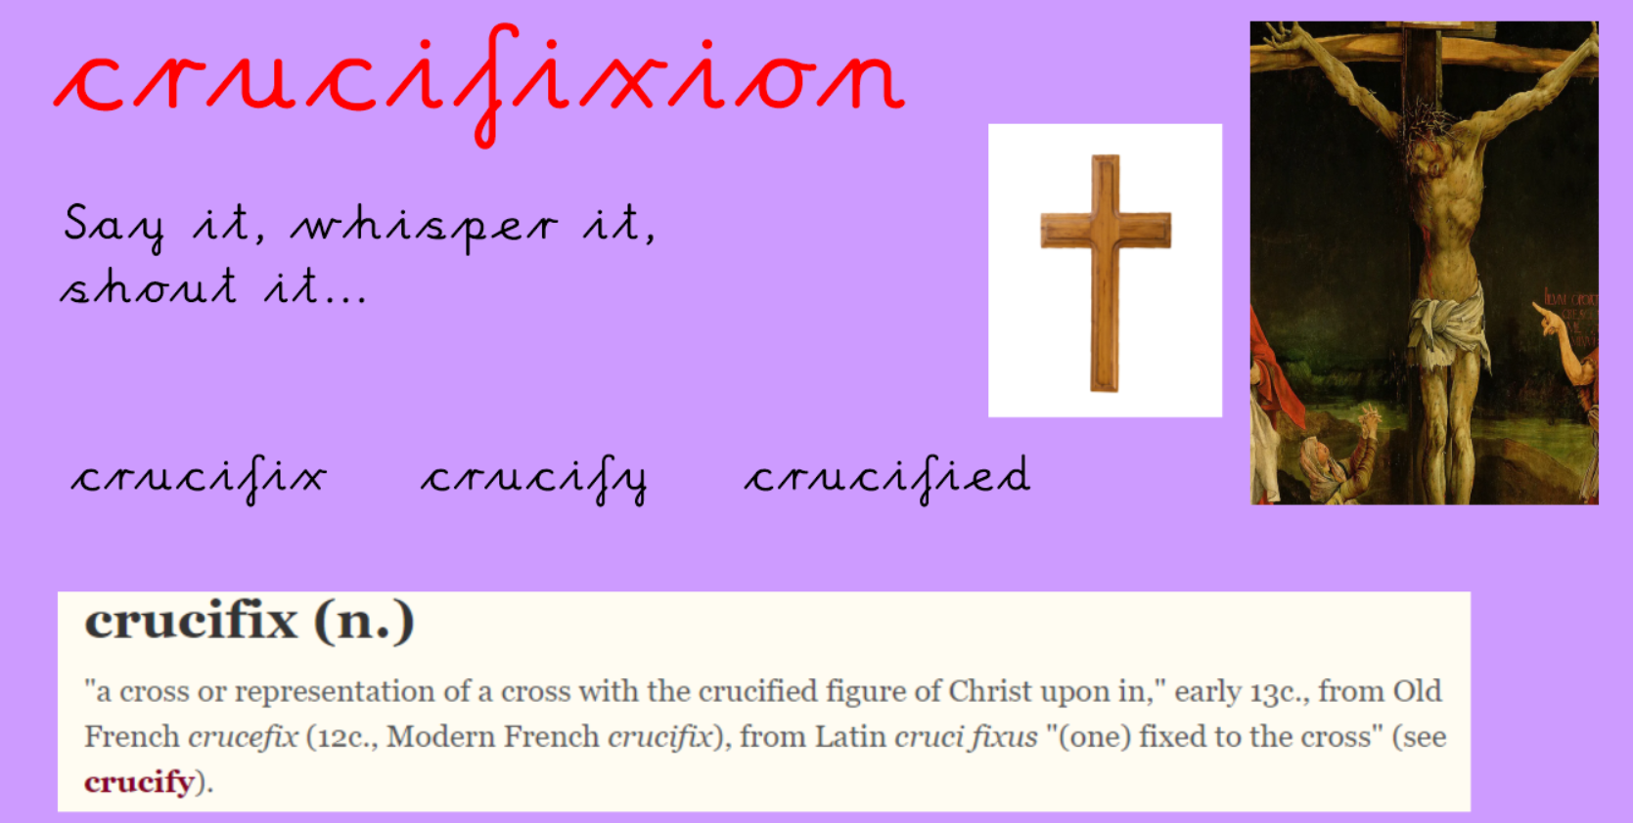
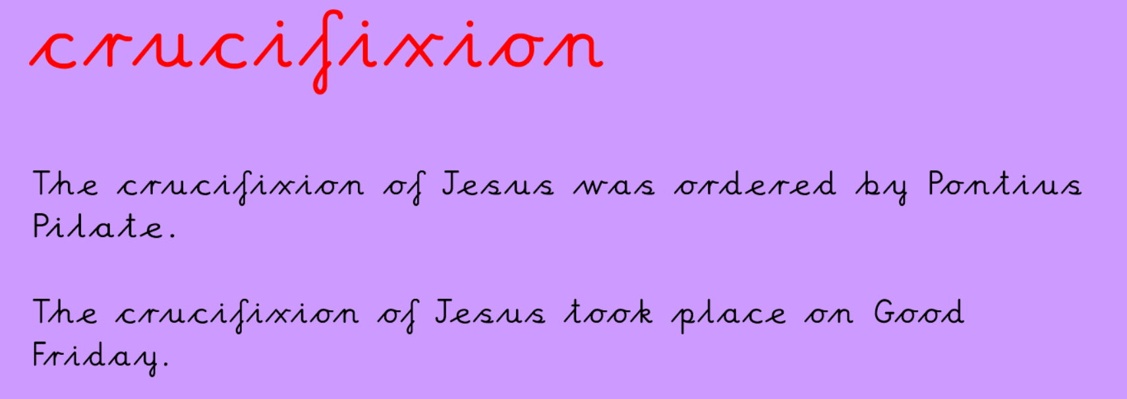

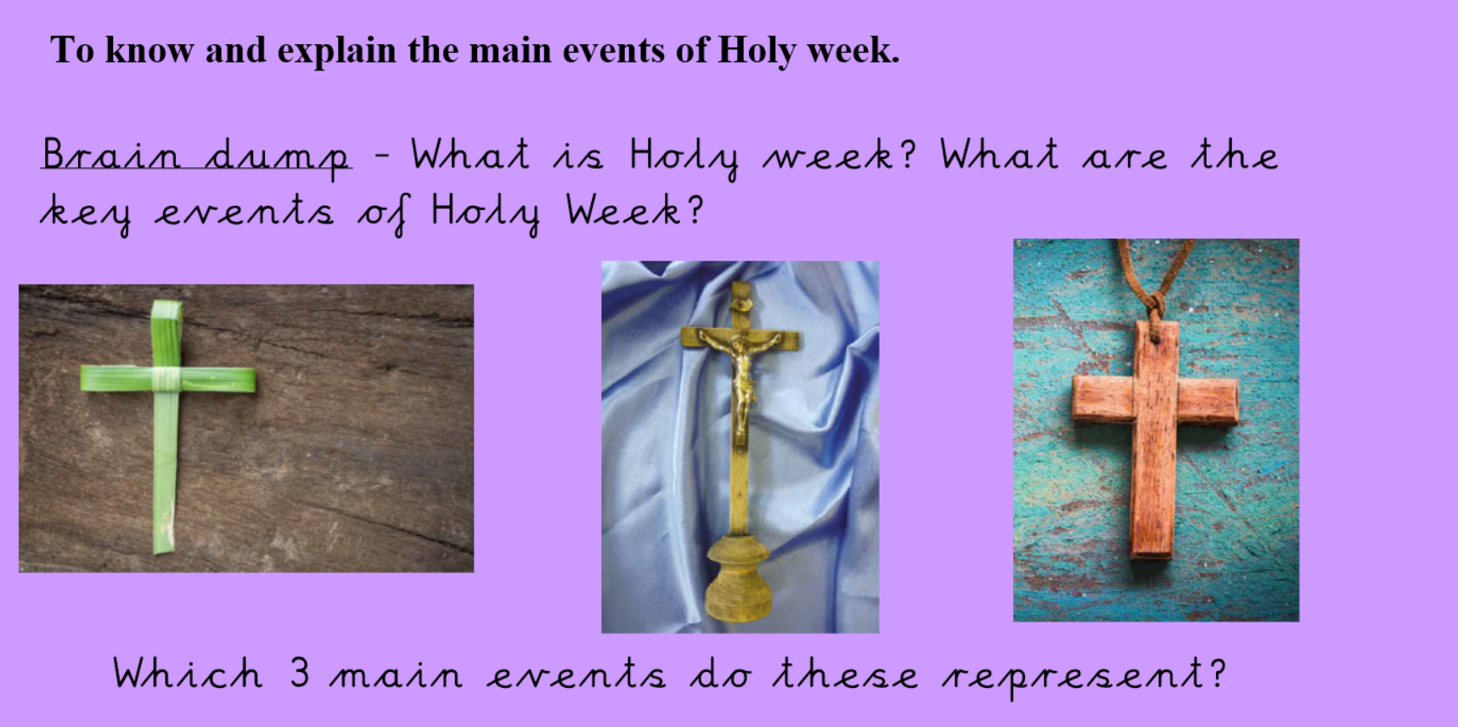
____________________________________________________________________________________________________________

Watch this video about how Holy week begins.
http://request.org.uk/festivals/holy-week-and-easter/palm-sunday/
(Link is on the website)
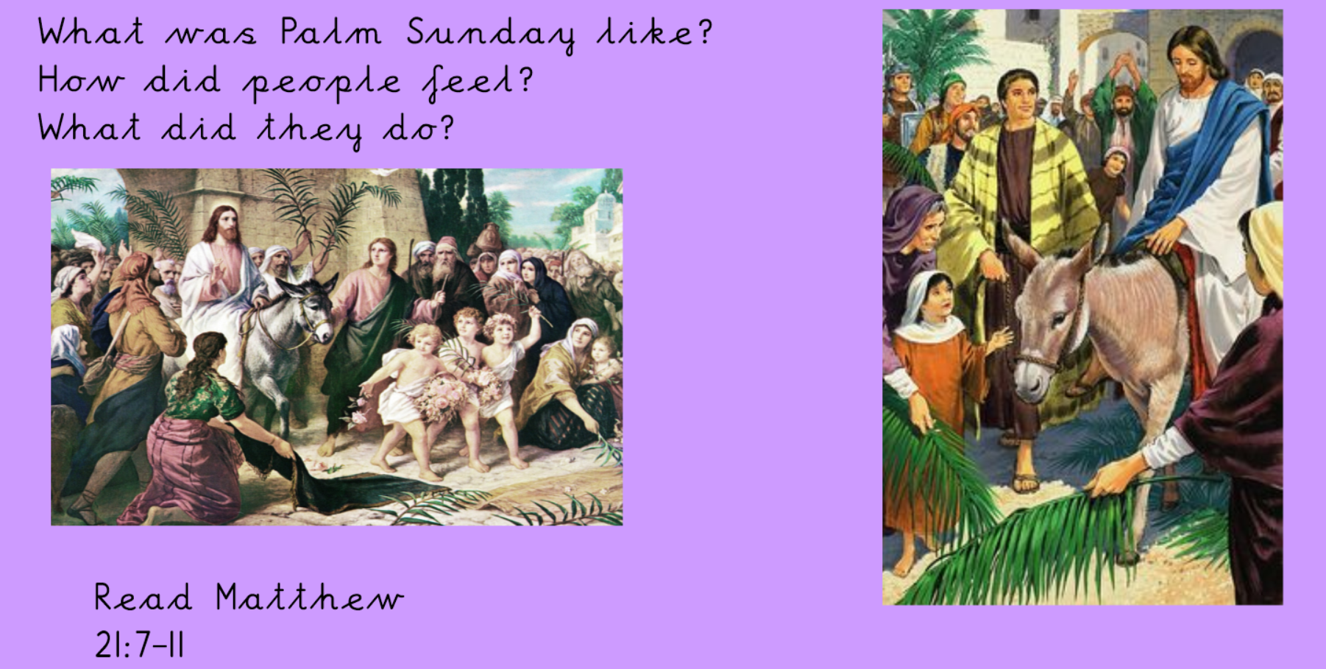
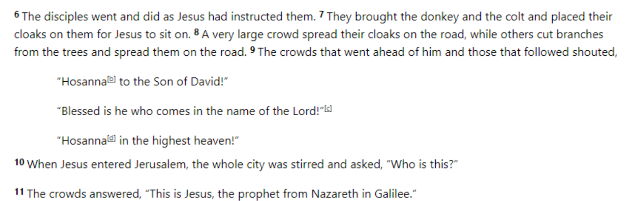
How do you think Mary, Mother of Jesus, felt during this event?

Jesus was crucified is the second main event of Holy week.
Read:

Luke 23: 32-48
32 Two other men, both criminals, were also led out with him to be executed.
33 When they came to the place called the Skull, they crucified him there, along with the criminals—one on his right, the other on his left.
34 Jesus said, “Father, forgive them, for they do not know what they are doing.” And they divided up his clothes by casting lots.
35 The people stood watching, and the rulers even sneered at him. They said, “He saved others; let him save himself if he is God’s Messiah, the Chosen One.”
36 The soldiers also came up and mocked him. They offered him wine vinegar
37 and said, “If you are the king of the Jews, save yourself.”
38 There was a written notice above him, which read: THIS IS THE KING OF THE JEWS.
39 One of the criminals who hung there hurled insults at him: “Aren’t you the Messiah? Save yourself and us!”
40 But the other criminal rebuked him. “Don’t you fear God,” he said, “since you are under the same sentence?
41 We are punished justly, for we are getting what our deeds deserve. But this man has done nothing wrong.”
42 Then he said, “Jesus, remember me when you come into your kingdom. ”
43 Jesus answered him, “Truly I tell you, today you will be with me in paradise.”

The Death of Jesus
44 It was now about noon, and darkness came over the whole land until three in the afternoon,
45 for the sun stopped shining. And the curtain of the temple was torn in two.
46 Jesus called out with a loud voice, “Father, into your hands I commit my spirit.” When he had said this, he breathed his last.
47 The centurion, seeing what had happened, praised God and said, “Surely this was a righteous man.”
48 When all the people who had gathered to witness this sight saw what took place, they beat their breasts and went away.

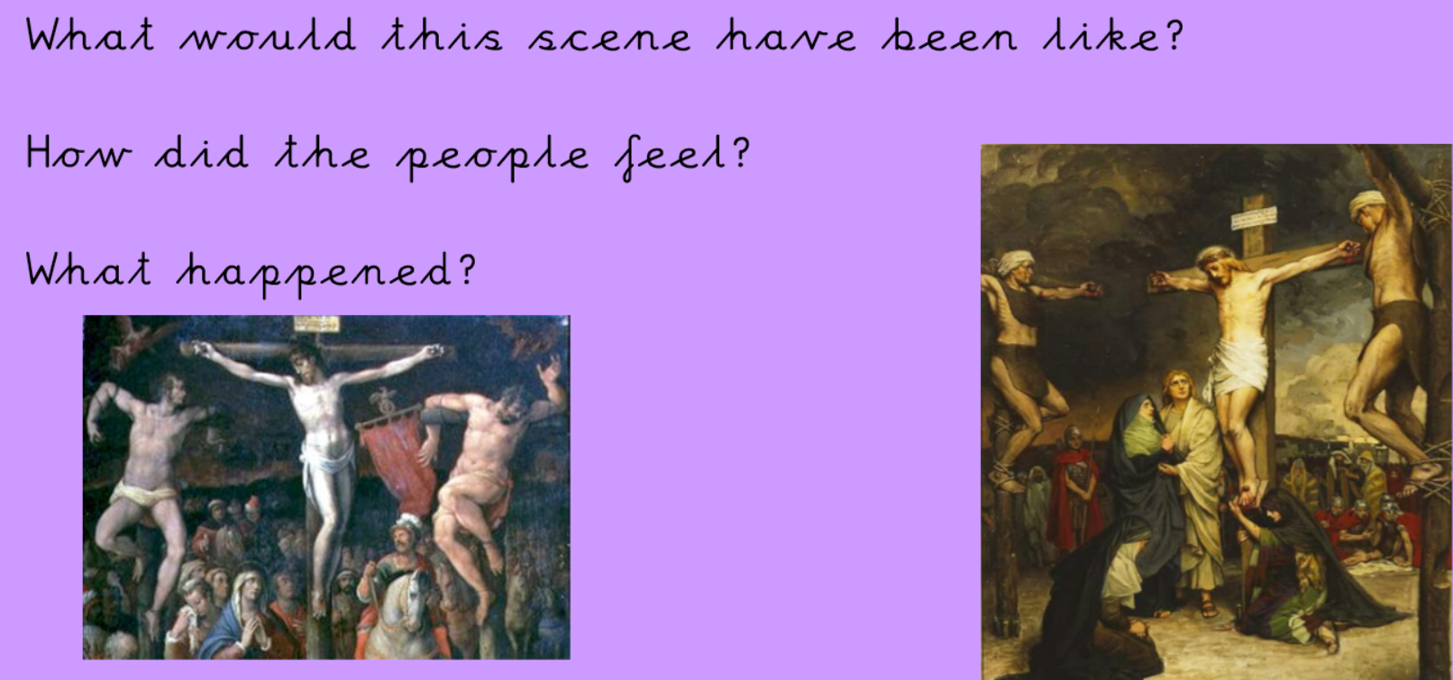
How do you think Mary felt during this event?

Jesus was resurrected is the third event in Holy week.
Read:
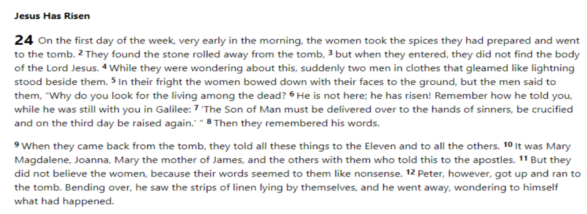
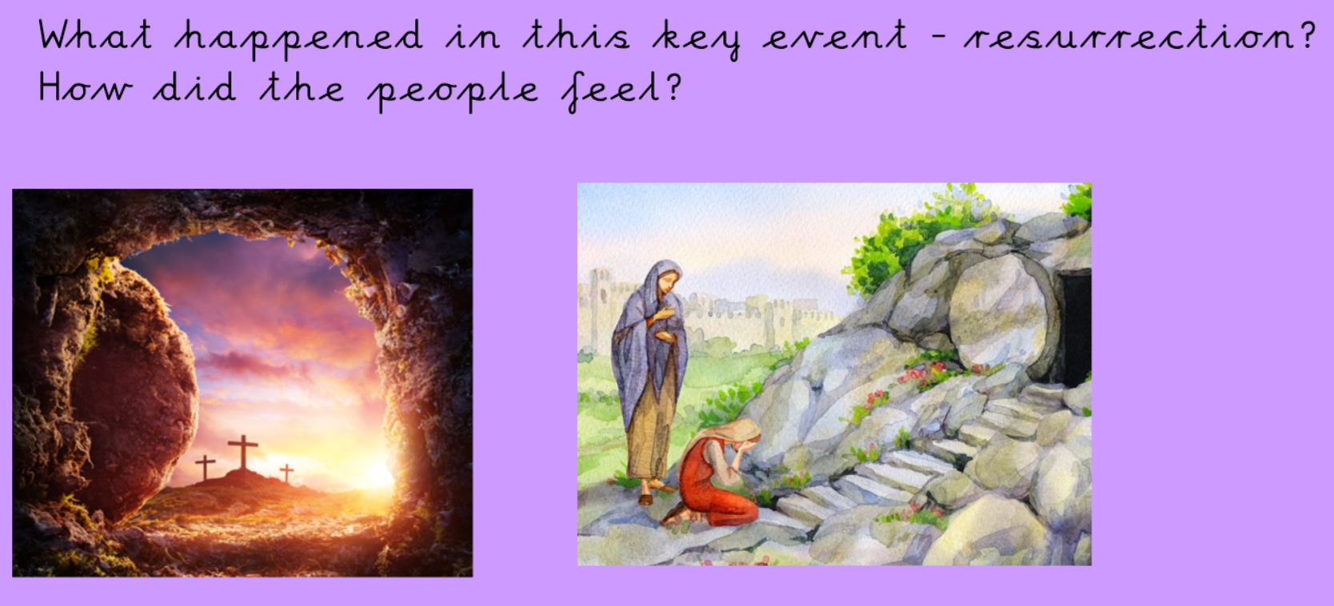
How do you think Mary felt during this event?

Complete the axis of emotion task for Mary.

